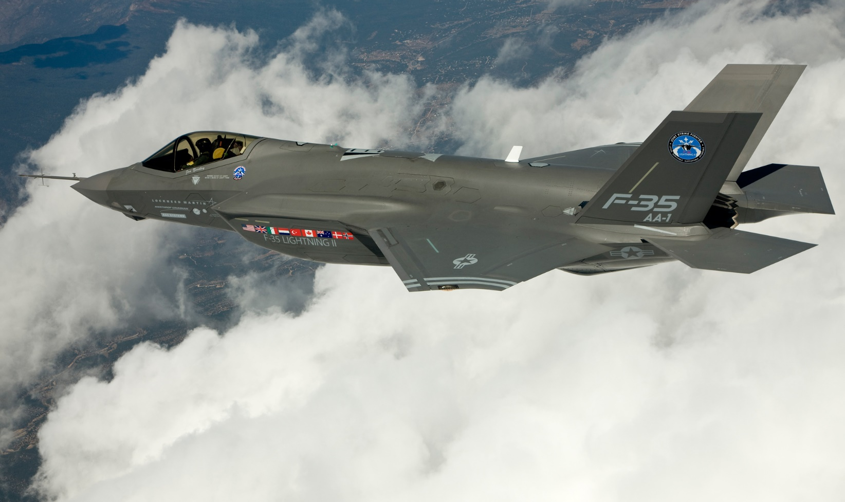

Environmental Excellence in Weapons System Acquisition, Large Program
F-35 Joint Program Office and Support Team
Environmental Awards
2020 Secretary of Defense

Introduction
The F-35 Lightning II Program is a United States (U.S.) Department of Defense (DoD) Acquisition Category I-D Program, under direction of a Program Executive Officer and managed by the F-35 Lightning II Joint Program Office (JPO), jointly led by the U.S. Air Force (USAF) and US Navy (USN). The F-35 Lightning II Joint Strike Fighter program includes three variants: F-35A conventional takeoff and landing (CTOL) variant; F-35B short takeoff/vertical landing (STOVL) variant; and F-35C carrier variant (CV). The F-35 Joint Strike Fighter will replace aging inventories of A-10s, F-16s, F/A-18s, AV-8B Harriers, Harrier GR7s, and Sea Harriers. The F-35 Environmental, Safety, and Occupational Health (ESOH) Team is the Joint Service, Government-Prime contractor team that is responsible for integrating ESOH into F-35 system engineering processes and acquisition strategy.

The F-35 Lightning II was designed and developed by the contractor team of Lockheed

Background
The F-35 Lightning II is designed and developed by the contractor team of Lockheed Martin (LM) Aeronautics in association with Northrop Grumman Corporation (NGC) and BAE Systems. It incorporates the F135 propulsion system designed and developed by Pratt and Whitney (P&W) in association with Rolls Royce. Final F-35 assembly takes place at LM in Fort Worth, Texas, Leonardo in Cameri, Italy, and Mitsubishi Heavy Industries in Nagoya, Japan, with components manufactured by thousands of suppliers from around the world. The USAF Life Cycle Management Center/Acquisition Environmental and Industrial Facilities (AFCLMC/EZV) and U.S. Naval Air Systems Command/Naval Air Warfare Center Aircraft Division (NAVAIR/NAWCAD) manage F-35 ESOH mitigation projects.
The international partners of the F-35 program include the U.S., United Kingdom, Italy, Netherlands, Canada, Australia, Denmark, and Norway. Foreign Military Sales (FMS) customers include Israel, Japan, South Korea, Belgium, Poland, and Singapore.
The three F-35 variants leverage common parts and systems, which contributes to its affordability. Support costs are about half that of present-day fighter aircraft. F-35s are mostly covered with composites in place of aluminum to make the aircraft light, saving fuel and supporting mission capabilities. The Air Force Research Laboratory (AFRL) analyzed ultrafine particles, carbon monoxide (CO), carbon dioxide (CO₂), nitrous oxide (NO_{x}), total volatile organic compounds (TVOCs), oxygen (O₂), ozone (O₃), sulfur dioxide (SO₂), and hydrogen cyanide (HCN) in composite burn emission and engine exhaust environmental exposure studies, and noted that the F-35 has shown to present no significant difference from modern commercial airplanes. Since its initial production, manufacturing costs have decreased by over 70% down to $77.9 million per F-35A that is expected to be delivered in 2022. The F-35 Program’s strategic international partnerships also boost the aircraft’s affordability by eliminating the need for redundant research and development and by providing access to intra-partner technology. About 500 F-35s have been produced as of February 2020, with 3,000 total aircraft planned for assembly.

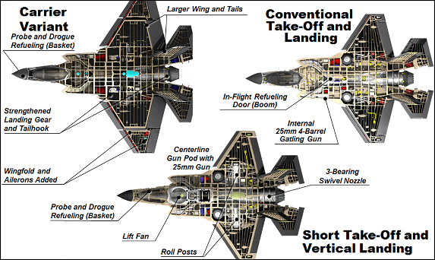
Three Joint Strike Fighter Variants
In part from ESOH team savings, production costs per F-35 has been cut over 70% from lot 1 to lot 14. Costs are down to $77.9 million per F-35A Conventional Take-off and Landing, $101.3 million per F-35B Short Take-off and Vertical Landing, and $94.4 million per F-35C Carrier Variant.

Program Description
The F-35 ESOH Team has been responsible for integrating ESOH into F-35 systems engineering processes and acquisition strategy from the inception of the program through manufacturing. Even though hundreds of aircraft have already been produced, the ESOH Team continuously assesses and improves their processes by implementing initiatives to eliminate hazardous materials, further reduce risk, and enhance resource efficiency. This continual evaluation approach will have a significant impact on mitigating environmental impacts, enhancing mission effectiveness, and improving cost efficiency. AFCLMC/EZV, NAVAIR/NAWCAD, and AFRL have collaborated with the F-35 ESOH Team to implement these successful initiatives.

Incorporating ESOH Integration into Systems Engineering Processes
The F-35 ESOH Team participates in the intensive F-35 site planning and activation process across the DoD and on behalf of international partners to ensure that system users, receiving installations, and training locations understand the system’s hazards, risks, and have the data they need to support site activations and National Environmental Policy Act (NEPA) documentation. ESOH requirements are then integrated into systems engineering processes by engaging Integrated Product Teams (IPTs) to plan initiatives, review their statuses, and mitigate any potential risks. ESOH criteria identified by IPTs are included in Systems Engineering Plans, Life Cycle Sustainment Plans, post-production planning documents, and demilitarization/disposal planning documents for installation use. During the last two years, the F-35 ESOH Team supported the activation of 15 sites in seven countries by conducting safety analyses, emissions characterizations, and hazardous materials program reviews to prepare for aircraft deliveries. The F-35 ESOH Team also provided aircraft maintainers’ guidance on ESOH hazards and mitigation practices.
ESOH Risk Management
The F-35 ESOH Team applies the methodology in Military Standard 882E (MIL-STD-882E), Defense of Defense Standard Practice System Safety, to identify hazards, evaluate risks, develop corrective actions, and track corrective action status. Risk management updates are coordinated with F-35 Program stakeholders at least annually via the F-35 Program ESOH Working Group and System Safety Group.
As part of the ESOH risk management for international program partners and foreign military sales customers, the F-35 ESOH Team performs a detailed gap analysis comparing U.S. ESOH laws and regulations to equivalent international requirements. U.S. regulations govern F-35 development and these analyses identify gaps or differing international requirements to ensure any ESOH risks are mitigated before the F-35 is deployed to international locations. This process ensures compliance with local environmental regulations, a successful international site activation, and unhindered operations.
Hazardous Materials Management and Pollution Prevention
The F-35 ESOH Team developed a Hazardous Materials Management Program to identify and minimize hazardous chemical usage throughout the manufacturing process. During Fiscal Years 2018 and 2019 alone, over 22 F-35 Program Pollution Prevention projects were in work by AFCLMC/EZV, JPO, LM, and NGC at the U.S. Air Force-owned F-35 manufacturing facilities in Fort Worth, Texas, and Palmdale, California.
Since the F-35 Program’s inception, the contractor team aimed to eliminate several classes of high-risk hazardous materials that were common in previous fighter aircraft manufacturing processes. F-35 Joint Strike Fighters are now manufactured without hydrazine, halon, Freon, and copper-beryllium bushings (i.e., bearings). The F-35 ESOH Team has significantly reduced the use of hexavalent chromium and cadmium materials and is implementing several initiatives to eliminate these materials completely. A lower VOC option for coating solvent blends was qualified (i.e., approved for use) resulting in over $2 billion total program savings and removing over 1,000 tons of VOCs from the production process.
Acoustic Data Collection
F-35 Acoustics Team members, including Air Force Research Lab and Naval Air Systems Command, analyze the F-35 acoustic environment. Analyses help to understand, communicate, and mitigate noise exposure in the community, in the cockpit, on the flight line, onboard aircrafts carriers, and in hardened aircraft shelters.
External Coordination of ESOH Risk Management
The F-35 ESOH Team maintains a schedule of actions and milestones required to comply with NEPA and Executive Order 12114, Environmental effects abroad of major Federal actions. These publicly coordinated environmental studies include analysis of how the F-35 Joint Strike Fighters may impact the local community.
Summary of Accomplishments
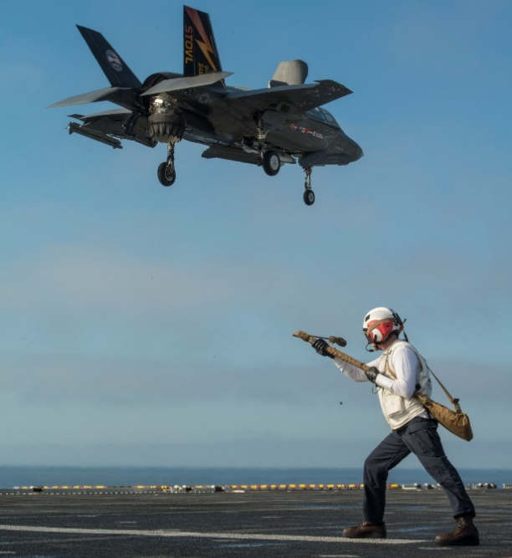
Characterizing the Acoustic Environment
Aircraft noise is most hazardous on the flight line, onboard aircraft carriers, and in hardened aircraft shelters. Understanding the acoustic environment where the F-35 will operate is critical to ensuring appropriate hearing protection and functional communication systems are provided to pilots and maintenance personnel. Hazardous noise to those working around the aircraft interferes with communication thereby decreasing safety and the chance of mission success and increases personnel risk of hearing related disabilities.
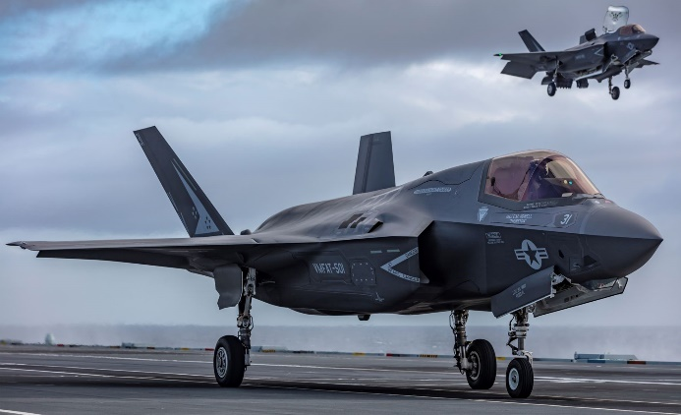
The F-35 Program Acoustics Team led two major acoustic measurement efforts in the Netherlands and Norway to support certification of F-35 operations in hardened aircraft shelters. AFRL, NAVAIR, and other members of the F-35 Program Acoustics Team collected and analyzed data for the F-35 acoustic environment, including far-field ground and flyover noise and flight profiles to model of community noise around F-35 bases, which is considered in mission planning and coordinated publicly in compliance with NEPA. This information was then used to develop maintainer and cockpit pilot noise exposure calculators and provide recommendations on hearing protection options to potential and all current domestic and international users of F-35 aircraft.
Cadmium Elimination from F-35 Program Tasks
Cadmium is a hazardous carcinogenic material and regulated as a hazardous waste under the Resource Conservation and Recovery Act (RCRA). RCRA has progressively lowered occupational exposure allowed by the United States Occupational Safety and Health Administration (OSHA). A pending European Union determination under the Registration Evaluation Authorization and Restriction of Chemicals regulation could completely eliminate cadmium from the European market, resulting in supplier restrictions, increased costs for non-local maintenance, and/or withdrawal from the marketplace. Cadmium usage ultimately puts F-35 aircraft maintenance personnel at higher risk and may potentially constrain the ability of installations to dispose of cadmium-containing fluids and solids.
Landing Gear Operating Environment
Zinc-nickel plating has been qualified and is being implemented in production in place of cadmium plating on the landing gear and the leading edge flap actuators, eliminating personnel cadmium exposure potential from common maintenance tasks. Uses of copper-beryllium bushings, hydrazine, halons, and Freon, previously common to military aircraft, have been completely eliminated from F-35.
The F-35 ESOH Team has been monitoring cadmium usage since the early development and production phases. Through careful ESOH design, early production F-35 aircraft used cadmium as a corrosion prevention coating in only the Leading Edge Flap Actuation System and Landing Gear. These components are often damaged and need to be replaced frequently. In an effort to eliminate the cadmium plating, the F-35 ESOH Team recently tested and successfully implemented a zinc-nickel plating alternative on both components. This replacement was already qualified at the principal landing gear depot at Ogden Air Logistics Complex, Hill AFB, supporting Hill AFB’s goal toward cadmium elimination and harmonizing the F-35 supply chain. As part of this qualification and in cooperation with AFLCMC, the F-35 Program is now procuring and deploying new waste-reducing brushless zinc-nickel re-plating field maintenance equipment, which eliminates the cadmium occupational exposure risk for F-35 maintenance personnel.
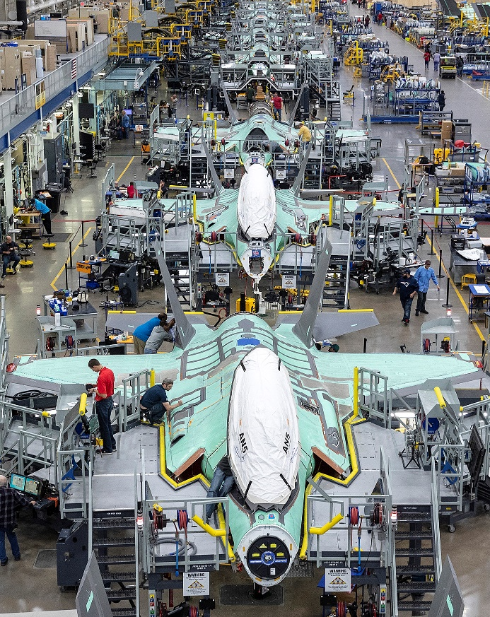
Eliminating Hexavalent Chromium
Hexavalent chromium is a heavy metal and known human carcinogen used in various forms
of primers, adhesives, sealants, and plating for protection against wear and corrosion. The F-35 ESOH Team has eliminated hexavalent chromium plating from F-35 external coatings and strictly limited the use of other hexavalent chromium-containing coatings, sealants, and primers. Eighty-eight percent of flight line equipment is currently free of hexavalent chromium. The largest remaining use of hexavalent chromium is the aircraft internal fuel tank coating, discussed below.

Hexavalent Chrome in Fuel Tank Coating
The F-35 aircraft’s chromated fuel tank coating is the last significant remaining usage of hexavalent chromium. The F-35 ESOH Team has been testing alternative non-chromated products since 2014 and recently identified a new non-chromated option. This new coating is undergoing field testing until 2021; however, no issues have been identified and it is expected to be incorporated into F-35 production as early as 2022. Although the current fuel tank is still chromated, the F-35 ESOH Team recently implemented a chromium-free touch up surface repair primer which requires less personal protective equipment during manufacturing and tank coating touch up activities. The new product also cures faster, saving time during production and reducing maintenance downtime.
F-35 Final Assembly
Hexavalent chromium has been eliminated from F-35 exterior coatings. Alternatives are being evaluated, tested, and implemented for remaining uses, with internal fuel tank coating being the largest remaining use, on track to be replaced in 2020. Photo Courtesy of Lockheed Martin.
Coating Material Substitution
It’s a WRAP
The current F-35 production process is labor intensive and requires the use of certain primers that produce a high volume of VOCs. The F-35 ESOH Team implemented a new Wipe Reactivation of Aged Primer (WRAP) process that removes the need to scuff or sand more than week old primer and apply fresh primer on assembled aircraft before applying a top coating. This new process minimizes primer exposure during the manufacturing process and eliminates 430 labor hours per aircraft. WRAP projects have been implemented for other primers and fasteners, reducing VOC emissions by 133 tons, and realizing a savings of $225 million over the production lifetime.
New Topcoats
The F-35 ESOH Team implemented the Extended Life Advanced Outer Mold Line (EL-AOML) topcoat system which eliminates the need for flex primer and topcoat layers used in the traditional coating system. The new topcoat system decreases the aircraft’s total weight by 54-60 pounds and is expected to reduce VOCs by 30 tons, realizing a savings of $287 million over the production lifetime. In addition, maintenance is simplified because repairs do not require extra time and materials to apply additional layers, saving an estimated $1 billion in operations and sustainment costs.
Paint Stripper Substitution
Removing NMP from the Paint Stripping Process
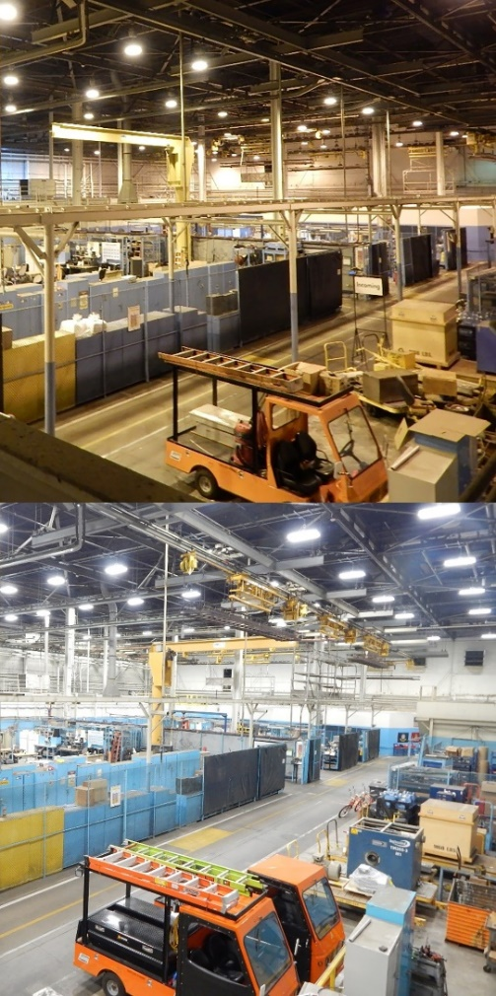
N-Methyl-2-pyrrolidone (NMP) is a reproductively hazardous chemical that is currently used in small amounts as an occasional paint stripper for specialty F-35 aircraft parts and processes. NMP is regulated under the Toxic Substances Control Act (TSCA) and by the European Union; however, it has been targeted for elimination. The F-35 ESOH Team is investigating a manual paint removal process to eliminate the necessity to use NMP. This will reduce the quantity of the tools required and personal protective equipment needed during the stripping process.

Paint Stripper for Non-Destructive Inspection
Most paint strippers qualified for use on military aircraft have contained methylene chloride, which is regulated under the TSCA and targeted for elimination. Currently there are no paint strippers used in field level maintenance; however, there will be a need to use strippers to support safety-related non-destructive inspection on F-35 aircraft parts in the future. The F-35 ESOH Team is investigating and testing non-methylene chloride paint strippers on F-35 metals to facilitate these inspections.

Environmental Performance Improvements at United States Air Force Plant #4 with LM Aeronautics
Manufacturing Facilities LED Lighting, Before and After
Air Force owned, Lockheed Martin and Northrop Grumman operated, facility optimization has cut production costs, improved workplace quality, and ensured compliance with environmental regulations. Reduced hazardous air pollutants have cut the costs of air quality management, reduced production time, and reduced facility footprints by mitigating the need for paint booths and air scrubbers. Implemented projects are estimated to save over $3 billion in life cycle costs. Photo Courtesy of Lockheed Martin.
United States Air Force Plant #4 (AFP#4) is a government-owned, contractor-operated facility in Fort Worth, Texas, where LM completes final assembly of U.S.-manufactured F-35 Joint Strike Fighters. AFLCMC/EZV works with LM to manage these facilities and mitigate environmental impacts.
- Light-emitting diode (LED) Lighting Upgrades: The F-35 ESOH Team initiated a facility-wide lighting upgrade project that replaced lighting in 13 buildings and has saved the Air Force $1 million annually over the last two years. Lumens have increased by 50%, power loads have decreased by 63%, and transformer deck loads are reduced by 20%, resulting in brighter work lighting and more efficient use of electricity.
- TES Tanks and Upgraded Chillers in Building 180: The F-35 ESOH Team installed Thermal Energy Storage (TES) tanks, which hold two million gallons of water and is equivalent to 32,000 ton-hours of cooling or four megawatts of refrigeration demand. This upgrade optimized chiller efficiency and realized a 6% reduction in energy demand. Replacing two chillers with more energy efficient models resulted in an annual reduction of 4.8 million gallons of condenser water.
- Rainwater and Condensate Collection Tanks: Treated grey water provides the source water for the TES, which otherwise would have been discharged to the sewer system. This reuse project has a return on investment of less than five years.
- Anti-Scale Treatment System: This treatment system prevents scale buildup on the interior walls of cooling towers and has saved an estimated 47 million gallons of water over the last three years.

Repositioning Fluid
Large and geometrically complex parts assembled during the F-35 production process require pressure sensitive adhesives. When an adhesive is misplaced, the part must be reworked or scrapped resulting in a large amount of waste and extended production times. The F-35 ESOH Team implemented a repositioning fluid to remedy these issues—The fluid is sprayed onto the surface before the adhesives are applied, providing a barrier and allowing the operator to properly place the adhesive prior to applying pressure. This additional step reduces both application time and quality by up to 40% and saves the program an estimated $54 million in scrapped parts and extended production times.
Environmental Saving at AFP#42 with NGC
Similar to AFP#4, AFP#42 is a government-owned, contractor-operated facility in Palmdale, California, where NGC manufactures the F-35 fuselage with oversight from AFLCMC/EZV, JPO, and LM. NGC and the F-35 ESOH Team qualified and implemented a low VOC internal aircraft coating, eliminating 21 tons of VOCs and reducing total emissions. This approach saved $1.8 million per year in operating costs, realized additional permit cost offsets otherwise required by California regulations, and eliminated the need for an $18 million acquisition for expensive VOC mitigation equipment. NGC and the F-35 ESOH Team also eliminated toluene and methyl isobutyl ketone from wipe solvents, resulting in 17,000 pounds reduction of toluene used in 2019.
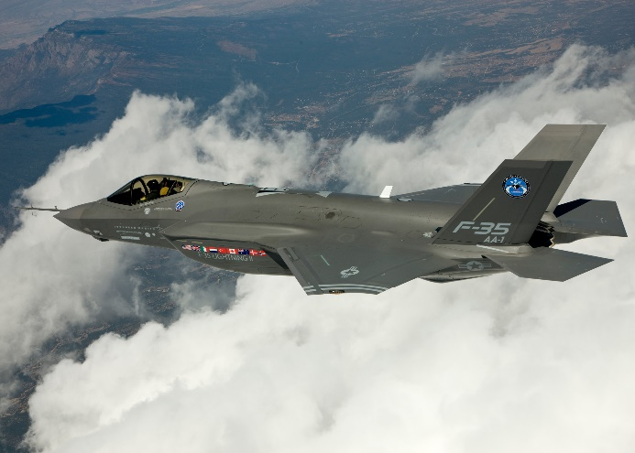
First F-35 Joint Strike Fighter in Flight
The F-35 ESOH Team works with United States and international customers and regulations to mitigate system ESOH hazards. Contributor logos pictured include (left to right): Lockheed Martin, Northrop Grumman, BAE Systems, Pratt & Whitney, General Electric, and the F-35 Joint Program Office. Program founding partner nations include: United States, United Kingdom, Italy, Netherlands, Turkey, Canada, Australia, Denmark, and Norway.

