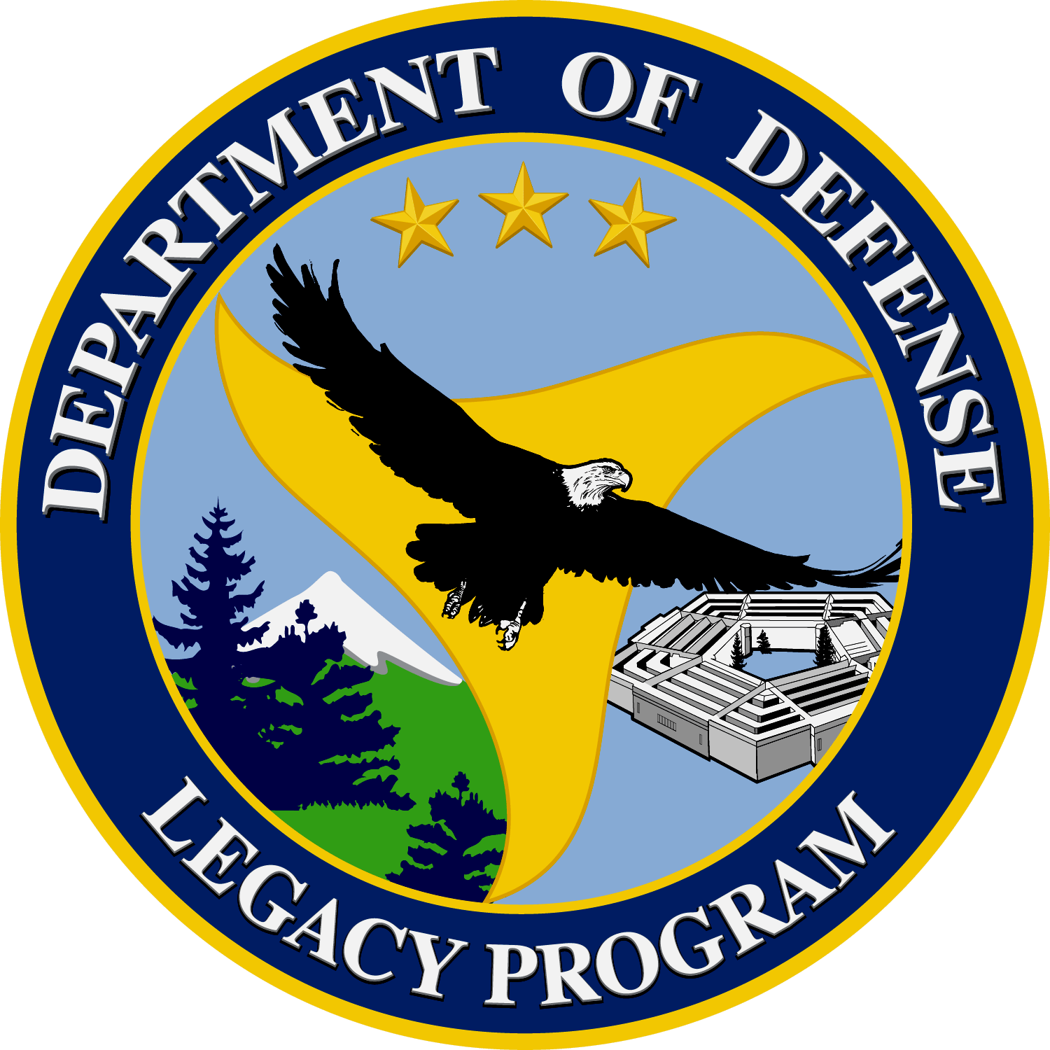 | Chesapeake Bay Program Interagency Partnership: Submerged Aquatic Vegetation | 00-36

Background:
The Chesapeake Bay is the nation’s largest estuary and is home to many species including the blue crabs and oysters. It is also a vital spawning area for several fish species such as herring, shad, and striped bass. The success of these species is dependant upon the health and water quality of the bay. Submerged aquatic vegetation (SAV) is a key factor of the bay’s health. The loss of SAV will lead to a decline in the health and stability of the bay’s channels. The Chesapeake Bay’s SAV is in need of immediate restoration and conservation and Department of Defense (DoD) installations in collaboration with the Chesapeake Bay Program are working to increase SAV and improve habitat.
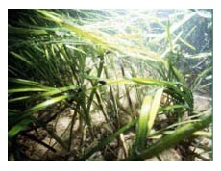
Photo by EPA
Submerged Aquatic Vegetation

Objective:
The DoD and the Chesapeake Bay Program’s goal was to find cost effective ways to analyze, monitor, and restore the population of submerged aquatic vegetation. A status evaluation of current SAV beds and protection of those areas was necessary to ensure the success of this project. The DoD installations have worked with monitoring and restoration operations and continue to do so with the help of other organizations and volunteers.

Summary of Approach:
The health of the Chesapeake Bay relies on the health of certain species living in its waters. This project, funded by the Legacy Resource Management Program, used existing restoration plantings to determine where the best areas were to continue SAV planting efforts. This in turn confirmed the vital role that SAV played in the health of the bay. Water quality monitoring had been used in the past and continues at 20 DoD installations along the Chesapeake Bay. These sites were distinguished by the usefulness of the data they provide to the Chesapeake Bay Program. A monitoring protocol was needed to quantify how many parameters were necessary to correlate water quality to the success of restored SAV beds. This was completed by the Chesapeake Bay Program and the Alliance for the Chesapeake Bay by developing a low-cost, long term monitoring protocol for land managers to use.

Benefit:
DoD’s installations mission to the stewardship of the land they occupy is evident through their participation in the monitoring and analyzing of the bay’s health. The information gained from monitoring showed what methods have and have not worked and what areas of the bay were still in need of help. The development of a low-cost monitoring program relieved financial burdens from land managers working to restore the bay’s health. Public involvement utilized in the monitoring processes further decreases costs of the bay’s restoration.

Accomplishments:
This project continued to restore 2 large areas and located new high-potential sites for more SAV restoration work. The restoration and preservation of the SAV areas provide more habitat for the declining populations of the blue crab, oyster, and fish species in the Chesapeake Bay. The increase of SAV also provides stabilization to reduce bank erosion and sediment build up. Land managers and volunteers are working through grants and other sources to continue the work of monitoring and restoring the Chesapeake Bay’s SAV.

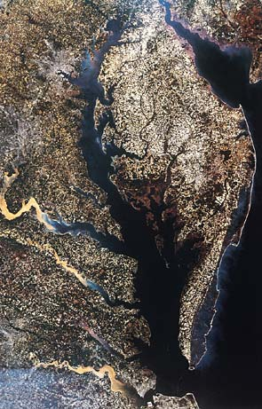
Photo from National Geographic
Chesapeake Bay Watershed

Contact Information:
Ms. Aileen C. Smith
Commander, Navy Mid-Atlantic Region, REC Division
9742 Maryland Avenue Code910, Suite 211
Norfolk, Virginia
(757)-449-3009 ext 3
acsmith@pwcnorva.navy.mil

