The Army is focused on Readiness and Modernization to defend those things most prized by all nations: our land, our natural resources, and our people. We are obligated to protect the natural resources that we defend.

The Army plays an important role in protecting endangered species. Endangered species protection is a win-win for the Army and nation. Over 254 endangered species are found on 125 Army installations. As the Army works to improve endangered species habitat, endangered species populations increase. When endangered species populations increase, the availability and capabilities of critical military maneuver areas and ranges improves and military readiness is enhanced. The Army has recovered endangered species populations, bringing them back from the brink of extinction.

Aberdeen Proving Ground (APG) Maryland, is critical to Army modernization and it is a leader in conservation of our national symbol, the American Bald Eagle. While APG is recognized as one of the world’s most important research, development, testing and evaluation facilities for military equipment and materiel, it is also home to a large and flourishing population of Bald Eagles. APG conserves some of the highest quality Bald Eagle habitat on the Chesapeake Bay. More than 300 Bald Eagle and over 70 active Bald Eagle nests are protected by U.S. Army at APG. Thanks in part to APG’s conservation efforts, this majestic bird of prey was taken off of the endangered species list in 2007.

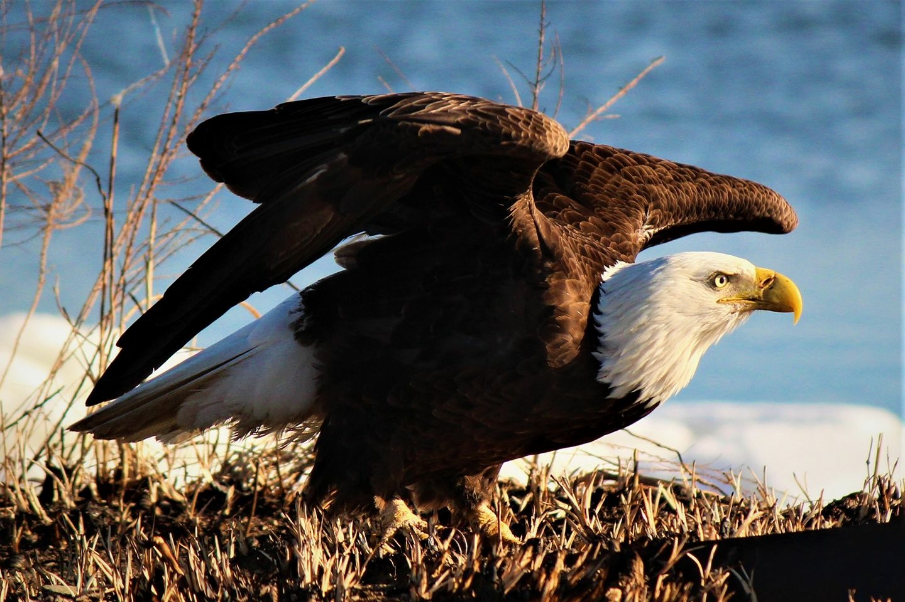
Bald Eagle, Aberdeen Proving Ground

Fort Bragg, North Carolina and Fort Stewart, Georgia. The recovery of Red-cockaded Woodpecker (RCW) populations at Fort Bragg, North Carolina and Fort Stewart, Georgia is one of our most notable successes in threatened and endangered species conservation. This is critical for the Army. Fort Bragg is home of the Airborne and Special Operations is one of the largest military complexes in the world. Fort Stewart is the Army's world-class training and military armored power projection combination on the eastern seaboard of the United States with tank, field artillery, helicopter gunnery, and small arms ranges operating simultaneously throughout the year. As Fort Bragg’s and Fort Stewart’s RCW populations recover and thrive, the viability and accessibility of over 320,000 acres of some of the Army’s most mission critical training lands is enhanced.
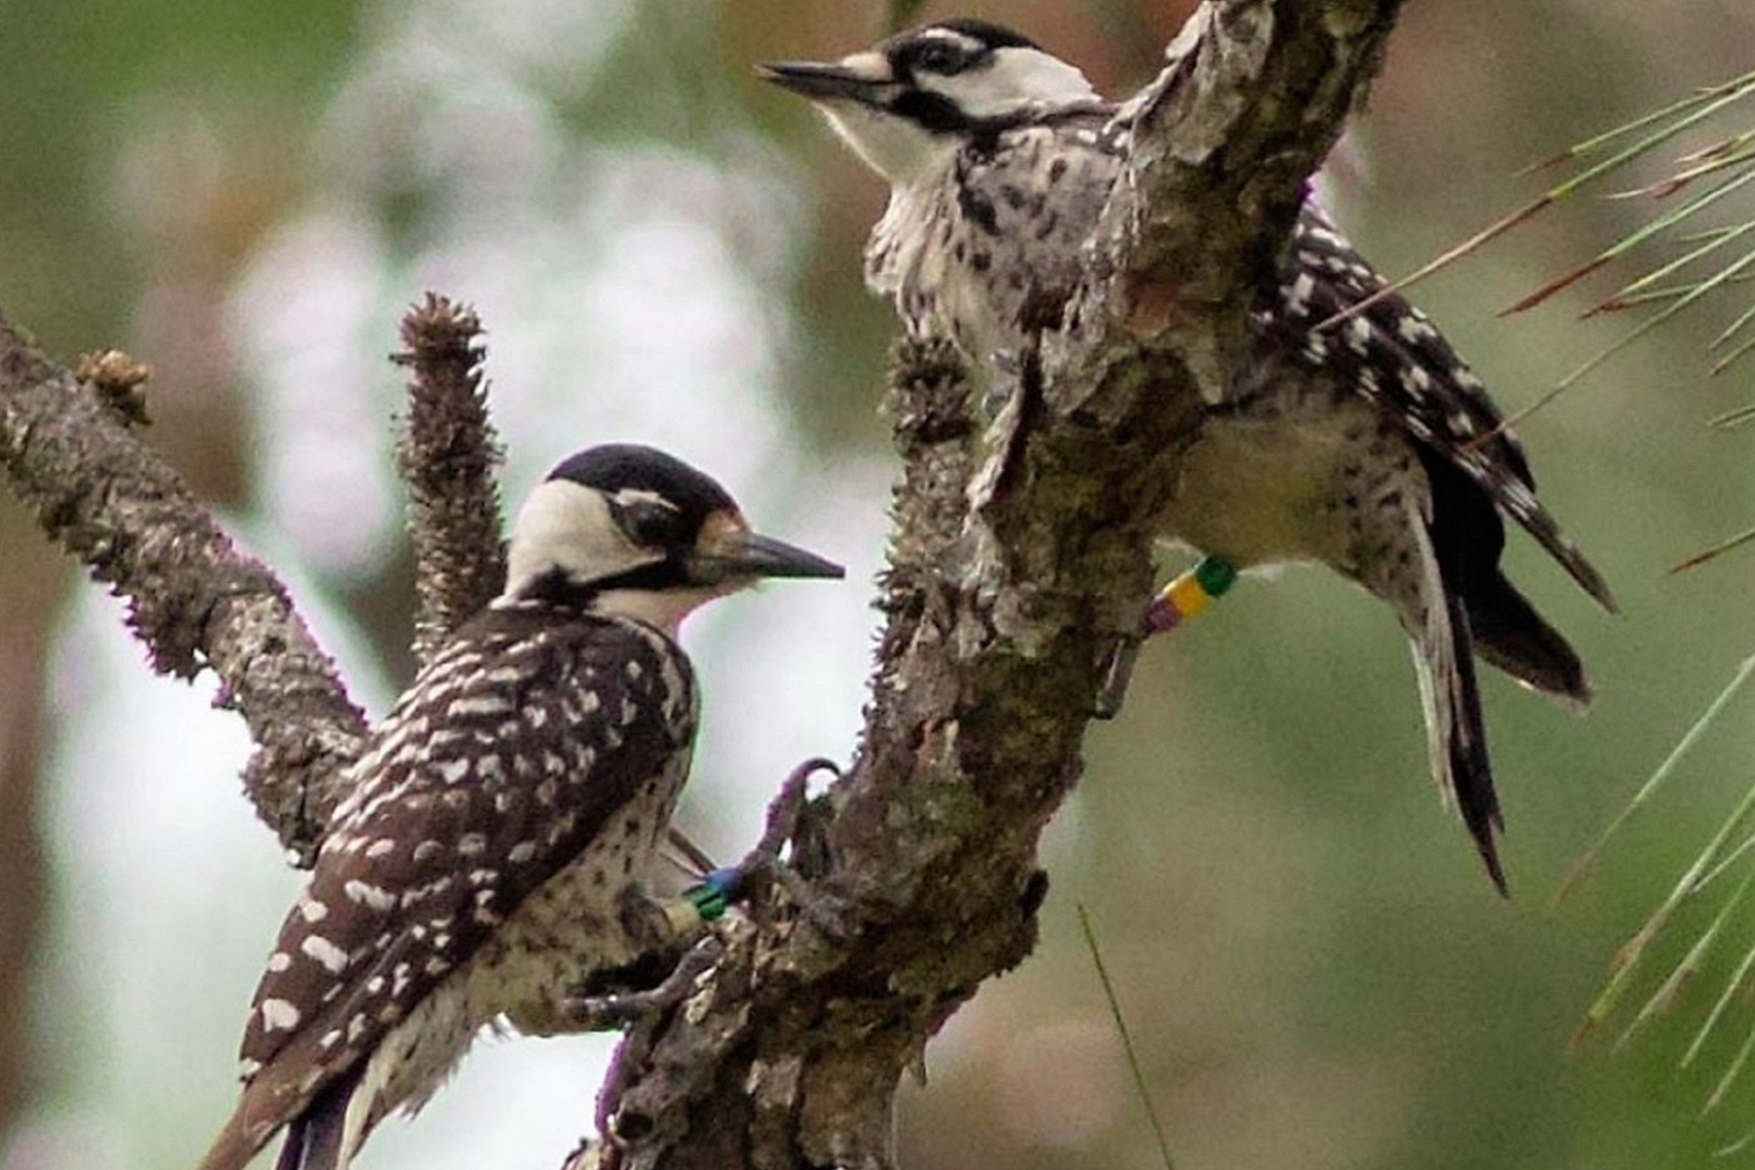
Red-cockaded Woodpecker, Fort Bragg

Fort Hood, Texas is the Army's premier installation to train and deploy heavy forces. A 214,968 acre installation, Fort Hood is the only post in the United States capable of stationing and training two Armored Divisions. At Fort Hood, the Army’s efforts to increase the populations of Black-capped Vireo and Golden-cheeked Warbler have been highly successful. In fact these efforts have been so successful that the US Fish and Wildlife Service has been able to take the Black-capped Vireo off of the endangered species list. At Fort Hood, as endangered species populations grow and thrive, over 70,000 acres of critical training lands now more fully support large scale military maneuvers.
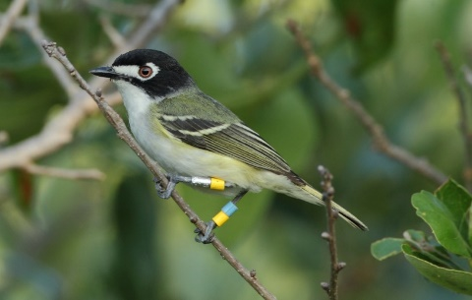
Black-capped Vireo, Fort Hood

Pohakuloa Training Area (PTA) contains 133,000 acres located between Mauna Loa and Mauna Kea volcanoes on the “Big Island” of Hawaii. The Army is working to help end native species extinction in Hawaii. PTA is the premier military joint/combined arms training facility in the Pacific region, and PTA contains one of the world’s rarest ecosystems: a tropical, sub-alpine, dry land ecosystem. Units from all U.S. military services, as well as allied militaries train at PTA because it offers realistic training opportunities not found elsewhere. The Army is managing 19 threatened and endangered species at PTA, some of these plant species are not found anywhere else in the world. For example, Tetramolopium arenarium in the Aster family was considered extinct in the Hawaiian islands until it was rediscovered by the Army at PTA in 1989. The Army is propagating seedlings of such very rare endangered plant species in our greenhouse at PTA for planting in the wild to help recover endangered species. In so doing, the Army ensures that endangered species conservation occurs in harmony with its military mission.
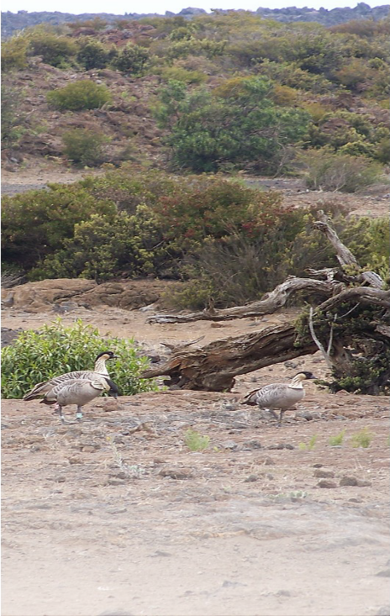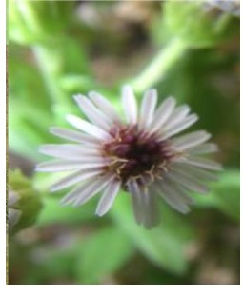
Endangered Hawaiian Nene inhabiting Tetramolopium arenarium at PTA
PTA are among the worlds rarest goose
species

