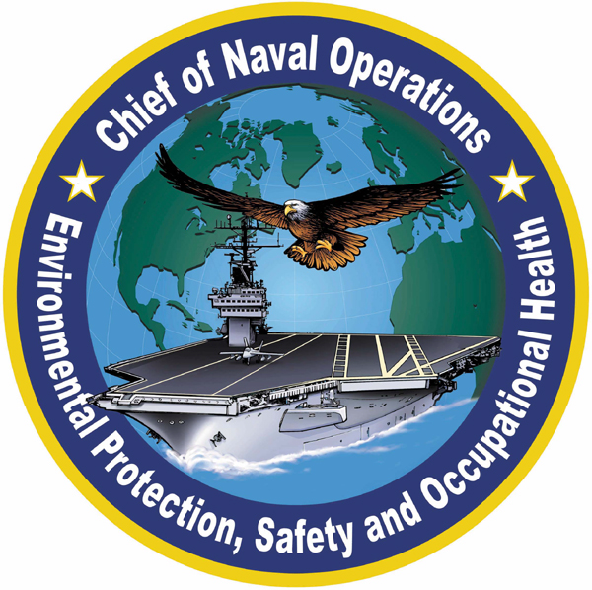 | Chief of Naval Operations, Occupational Safety  and Health Branch (CNO N09FB4)

Mark B. Geiger, M.S., CIH, CSP
Occupational Safety and Health Manager
Safety and Health in Acquisition (N09FB)

Mr. Geiger is assigned as Occupational Safety and Health Manager for Safety and Health in Acquisition. He was selected in 2001 to fill this newly established position to spearhead the CNO’s initiative to incorporate safety into the acquisition of major military systems. Mr. Geiger develops occupational safety and health policy and provides technical assistance to Echelon 2 commands on acquisition matters and assists the Naval Safety Center and CNO on other occupational safety and health considerations.

Mr. Geiger was awarded a Master of Science in Environmental Engineering from the Civil Engineering Department of Catholic University in1998. He also holds a Master of Science in Environmental Health Sciences from the University of Cincinnati and a Bachelor of Science in Biology from Earlham College, Richmond, Indiana. Mr. Geiger has also earned certifications in industrial hygiene (CIH) and safety management (CSP).

Mr. Geiger previously served as Head of the Occupational Health and Industrial Hygiene Departments at Marine Corps Base, Quantico, Virginia. His accomplishments include updating industrial hygiene procedures, implementing tracking of safety deficiencies with a requirement that recipients report on the status of corrective actions within 30 days. Mr. Geiger also standardized methods for evaluating indoor air pollution complaints. His consolidation of indoor air pollution investigations established a database that streamlined abatement of recurrent indoor air pollution concerns.

Mr. Geiger worded from 1993 to 1999 at the Armed Forces Radiobiology Research Laboratory in Bethesda, Maryland as Head of its Occupational Safety and Health Division. He managed hazardous waste disposal, developed air emissions inventory and SARA Title III reporting, and managed all non-radiological aspects of occupational safety, industrial hygiene and environmental programs. Mr. Geiger developed several hazardous material management and waste minimization initiatives, including training on EPA regulations on hazardous waste management that saved over $38,000 and developed a model for saving the command $477,000 on hazardous waste disposal.

Mr. Geiger served as Industrial Hygiene and Environmental Program Manager for Military Sealift Command from 1991 to 1993. He managed industrial hygiene, occupational health, chemical safety, and environmental protection policy implementation, including compliance with the Oil Pollution Act of 1990. His prior positions also include Safety and Health Manager for VA Medical Center, Milwaukee, Wisconsin, the first industrial hygienist assigned to the U.S. Army clinical center and industrial maintenance operations in Landstuhl, Germany, and as a field industrial hygienist for major Navy activities in the Norfolk area.

Mr. Geiger also serves on the Board of the Potomac Section of the American Industrial Hygiene Association and is also a member of the American Society of Naval Engineers and the International System Safety Society. He is also a literacy volunteer who tutors adults in reading, writing, and speaking English. He lives in Fairfax, Virginia with his wife Alexandra, His daughter, Nicole is a recent college graduate with a BS in Nursing and works as a nurse in San Diego area.

