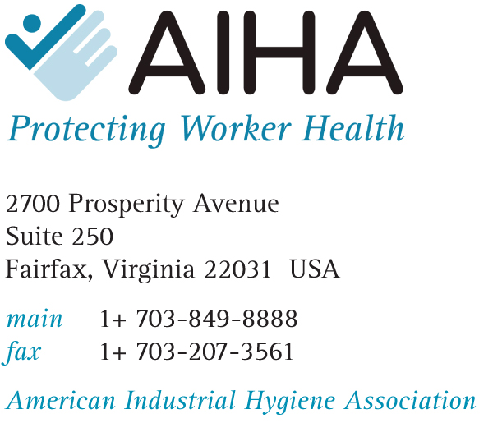

Biography
Aaron K. Trippler

Aaron Trippler is Director of Government Affairs for the American Industrial Hygiene Association (AIHA). Mr. Trippler directs government affairs for more than 70 local sections and is chief liaison with Congress and federal agencies. He has served in this capacity since 1992, when he developed the AIHA government affairs program.

In directing federal affairs, Aaron is responsible for following all federal legislation and regulations, as well as drafting AIHA Congressional testimony and working with numerous federal agencies on the public policy issues of AIHA.

Aaron also directs state government affairs for AIHA, annually reviewing nearly 3,500 pieces of state legislation and regulations affecting the profession of industrial hygiene and testifying when needed.

Aaron has 30 years experience in federal and state government affairs and has developed government affairs programs for three national associations. He holds a BS degree in Business Administration.

