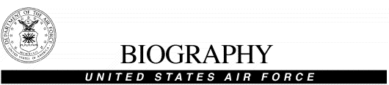MR. JOHN D. PHILLIPS

Mr. Phillips is the Air Force Chief of Ground Safety. He leads the overall ground mishap prevention program for USAF operations and personnel worldwide. He oversees ground safety policy, plans, programs, and standards development and implementation for over 550,000 military and civilian personnel. As the senior USAF ground safety liaison to sister Services, allied Air Forces, Federal Agencies, and the private sector, he establishes and maintains proactive safety partnerships worldwide. Mr. Phillips represents the Air Force Chief of Safety as chairperson/member on Air Force, Department of Defense, national, and international councils, boards, panels, and working groups. Also provides leadership and force development for 900+ military and civilian career safety professionals AF-wide.

Mr. Phillips entered federal service in 1981 when he enlisted in the Army and initially served as a helicopter crewchief. In 1983 he was accepted into the Army’s Warrant Officer Flight Program where he graduated as an aeroscout aviator and was subsequently assigned to a variety of Air Cavalry units. His flight experience includes UH-1, OH-58, and AH-1 helicopters. In addition to his flight assignments, Mr. Phillips has held a wide variety of safety positions at levels ranging from squadron to HQ USAF. His safety experience includes duties as flight safety officer, weapons and range safety officer, installation chief of safety, and ground safety manager both while on active duty and as an Army and Air Force civilian. His most recent assignment was as Chief of Air Force Safety Policy and Plans, Headquarters United States Air Force.

Mr. Phillips is a Certified Safety Professional and has a Master of Science degree in Industrial Safety Management from Central Missouri State University. He is a graduate of Harvard University’s Kennedy School of Government Senior Executive Fellows Program and the Federal Executive Institute’s Leadership for a Democratic Society Course. He has received a number of awards including the Air Force Civilian Meritorious Service medal.

