COLONEL JOHN J. CIESLA
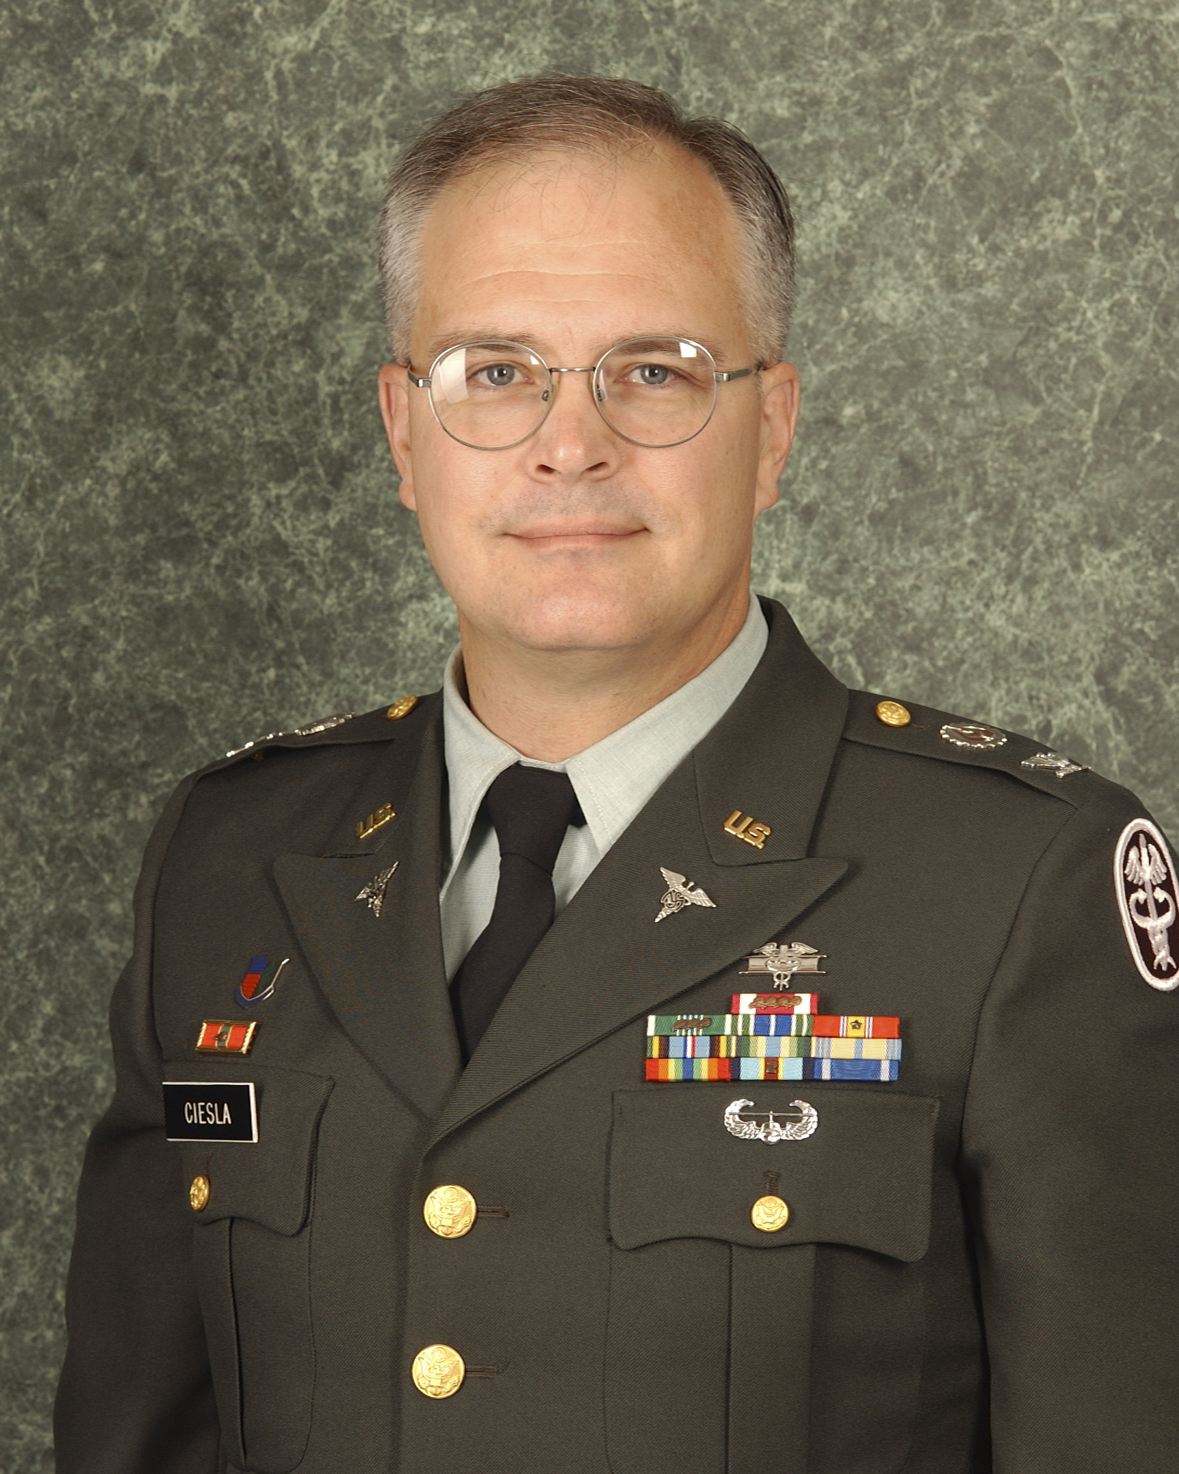
Colonel John J. Ciesla was born in Duluth, Minnesota and received his Bachelor of Science degree in Biology from the University of Minnesota, Duluth, and his Master of Science Degree in Environmental Health from the University of Minnesota School Of Public Health in Minneapolis, Minnesota. Upon entering the Army in October 1980, COL Ciesla attended the Army Medical Department (AMEDD) Officer Basic Course at Fort Sam Houston, Texas.

Upon completing the AMEDD Officer Basic Course, COL Ciesla was assigned as the Division Preventive Medicine Officer for the 101st Airborne Division (Air Assault). In January 1983, he assumed duty as the Chief, Environmental Health Services, 67th Evacuation Hospital, in Wuerzburg, Germany. COL Ciesla returned to Fort Sam Houston in December 1985 to attend the Combat Casualty Care Course and the AMEDD Officer Advanced Course.

In June 1986 he reported for duty at Fort Hood, Texas and assumed command of the 224th Medical Detachment, 1st Medical Group, 13th COSCOM. After this command assignment, COL Ciesla was assigned to the U.S. Army Medical Department Activity (USAMEDDAC) at Fort Hood in August 1988 as the Chief of Environmental Health for the installation Preventive Medicine Service.

COL Ciesla returned once more to Fort Sam Houston in April 1991 to serve as an Instructor in the Environmental Quality Branch, Preventive Medicine Division, AMEDD Center and School, eventually serving as the Chief, 91S Training Section and Chief, Industrial Hygiene Training Section.

In July 1994, he joined the newly activated 30th Medical Brigade in Heidelberg, Germany as an Environmental Science Staff Officer. In this capacity COL Ciesla deployed to Bosnia in 1996 as part of Task Force Eagle – the U.S. component of the NATO Implementation Force for the Dayton Peace Accord. Upon returning to Germany, COL Ciesla assumed duty as the Executive Officer for the 93rd Medical Battalion in Heidelberg.

Upon returning to the United States in July 1997, COL Ciesla served in the Health Policy and Services Directorate, Office of The Surgeon General, Falls Church, Virginia. In September 1998, he assumed duty as the Officer in Charge of the Center for Health Promotion and Preventive Medicine – West (USACHPPM-West) Advance Party at Fort Lewis. COL Ciesla assumed command of USACHPPM-West from March 1999 to June 2001. From July 2001 until June 2002, he served as the first Preventive Medicine Operations Officer for the I Corps Surgeon’s Office at Fort Lewis. In July 2002, COL Ciesla assumed duties as the Program Manager for the Health Hazard Assessment Program at USACHPPM, Aberdeen Proving Ground, MD. In July 2003, COL Ciesla assumed duty as the USACHPPM Chief of Staff and Troop Commander. On 2 March 2004, COL Ciesla became the Acting USACHPPM Commander and served in this capacity until 23 September 2004 when he resumed duty as the USACHPPM Chief of Staff. From August 2006 until July 2007, COL Ciesla served as the Chief of Staff for the Europe Regional Medical Command and assumed his current position as Military Deputy to the Deputy Assistant Secretary of the Army for Environment, Safety, and Occupational Health in July 2007. COL Ciesla concurrently served as Assistant Chief of the Medical Service Corps for Preventive Medicine Sciences and Environmental Science and Engineering Consultant to the Army Surgeon General from June 2004 to July 2008.

COL Ciesla’s awards and decorations include the Legion of Merit, Meritorious Service Medal (6 awards), Army Commendation Medal (4 awards), Army Achievement Medal (2 awards), the Armed Forces Expeditionary Medal, the Global War on Terrorism Expeditionary and Service Medals, the NATO Medal, the Expert Field Medical Badge, the Air Assault Badge, and the Order of Military Medical Merit. COL Ciesla has also been awarded the “A Designator” by the Surgeon General for his expertise in Environmental Sciences.

COL Ciesla has two daughters, Cassandra (Ciulla) and Jessica (Scheutz), and a son, Jacob.

