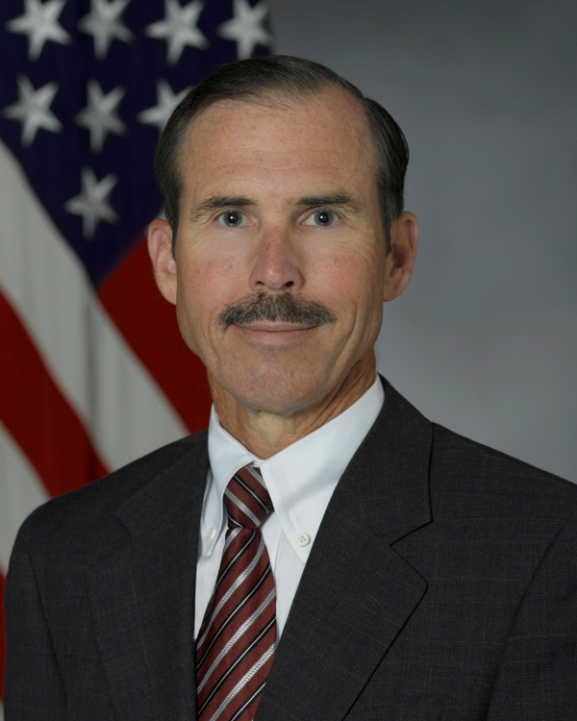
Tom Rollow was sworn in June 12, 2006 as the Deputy Assistant Secretary of the Navy (Safety). As the Deputy Assistant Secretary of the Navy (Safety), he advises the Secretary of the Navy, through the Assistant Secretary of the Navy (Installations and Environment), on all matters pertaining to mishap prevention, personnel safety and the preservation of material resources. His responsibilities include policy, oversight, and advocacy of safety, occupational health, and fire protection programs affecting approximately one million uniformed Navy and Marine Corps personnel, and Department of the Navy civilian employees and contractors.
Prior to joining the Department of the Navy, Mr. Rollow spent 16 years at the US Department of Energy where he held various Senior Executive Service positions related to nuclear and occupational safety of atomic weapons design, production, and maintenance; clean up of toxic and radioactive waste, a legacy of nuclear weapons production and research during the Cold War; research being performed at the Nation’s leading scientific laboratories; and nuclear reactor research, design, and operation. Positions that he held included: Director Nuclear Safety Field Programs, Deputy Assistant Secretary of Energy (Nuclear Safety), Director of the Office of Operating Experience Analysis and Feedback, Director of the Office of Special Projects and Investigations, and Director of the Office of Worker Advocacy.
Previous to this, Mr. Rollow spent 15 years in the US Navy’s Naval Reactors organization, Naval Sea Systems Command Code 08, where he held several senior management positions related to nuclear powered Naval ship design, construction and operation. Positions of note include heading up the fluid and mechanical design of the Moored Training Ship Project, which involved conversion of the ex-SSBN635 USS Sam Rayburn to operate dockside at the Charleston SC Naval Weapons Station for the purpose of training Navy nuclear operators. He later transferred to the Charleston site as the first Naval Reactors Representative and oversaw the construction, staffing, and set up of support facilities and organizations for the Moored Training Ship. The project was so successful that a second ship was later modified and installed at the site.
Mr. Rollow received a B.S. (cum laude) in Mechanical Engineering from Tulane University in 1975, an M.S. equivalent in Nuclear Engineering from the Bettis Atomic Power Laboratory Reactor Engineering School (non-accredited) in 1976, and an M.S. in Engineering Administration from The George Washington University in 1979. He was commissioned as a Naval Officer in 1975 and retired as a Naval Reserve Captain in 2005. Mr. Rollow is also a graduate of the Harvard University John F. Kennedy School of Government Program for Senior Managers in Government, and a licensed Professional Engineer in the Commonwealth of Virginia.

