Richard L. Wright, CIH
Chief, Safety and Occupational Health

U.S. Army Corps of Engineers

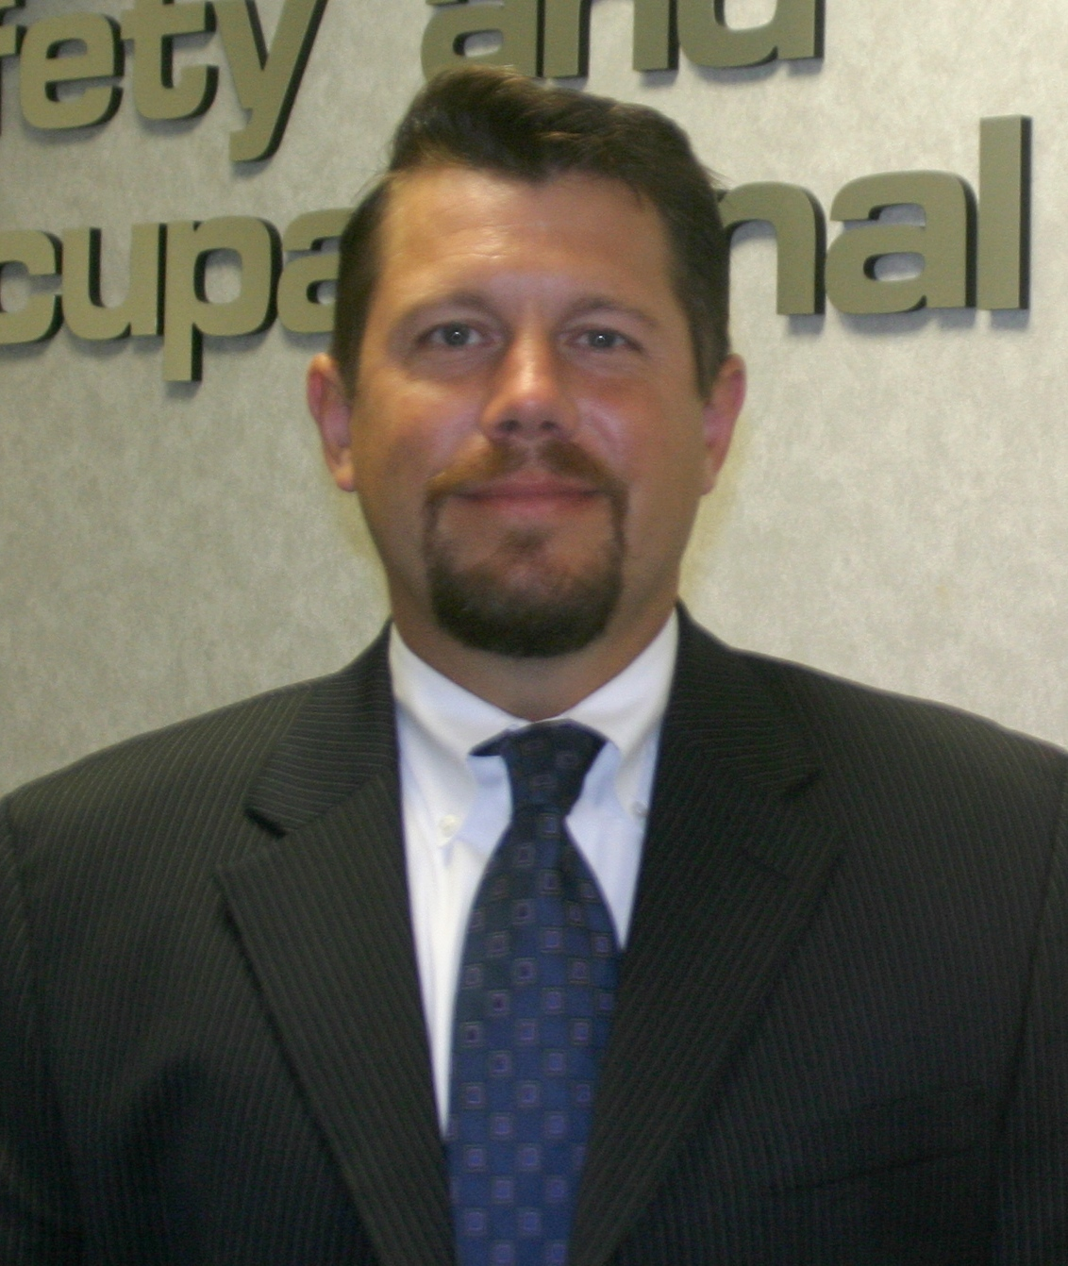
Mr. Wright currently serves as the Chief, Safety and Occupational Health, Headquarters, U.S. Army Corps of Engineers (USACE). As the senior safety and occupational health authority for the USACE, Mr. Wright advises and counsels the Commander, Deputy Commanders, Directors and key officials on all safety and occupational health aspects of the broad programs and missions executed by the USACE. Mr. Wright is responsible for developing and executing safety and health policy and objectives across the worldwide command consisting of over 35,000 civilian and military personnel, as well as a contractor workforce involving 85 million man-hours of exposure annually, substantially all of which represents exposure of a high risk nature.

Mr. Wright’s prior position was as the Director, Safety and Occupational Health, Office of the Deputy Assistant Secretary of the Navy (Safety). Mr. Wright provided policy and management oversight to various safety and occupational health related programs at the Secretary of the Navy level. These programs included injury prevention, fire and emergency services, explosives safety, weapons safety, laser and nuclear / radiation safety, and occupational health. These programs affected the mission readiness of approximately one million Sailors, Marines, civilians, Reservists, and contractors.

Mr. Wright also served as the Senior Industrial Hygienist and Radiation Protection Staff Officer for Headquarters, USACE. Mr. Wright managed the safety / occupational health and radiation safety programs for the Corps’ environmental and unexploded ordnance remediation work. Mr. Wright was instrumental at ensuring employee and contractor safety was maintained during actions within the Corps’ Formerly Utilized Sites Remedial Action Program, which focused on cleanup of former Manhattan Project nuclear facilities, as well as EPA Superfund and DoD remedial action programs.

Mr. Wright served on Active Duty in the U.S. Army (Medical Service Corps branched), during which time he served in several capacities. As an Army Captain, he served as a Program Manager at the U.S. Army Center for Health Promotion and Preventive Medicine. His program provided industrial hygiene, occupational health, safety engineering, and chemical weapons protection services to Army personnel deployed worldwide. Mr. Wright was instrumental in ensuring the protection of Soldiers and personnel from chemical warfare agent exposures via his work in support of the DoD Chemical Weapons Demilitarization Program. Mr. Wright continued serving in the U.S. Army Reserves.

Mr. Wright began his safety and occupational health career at IBM Corporation’s T.J. Watson Research Center in Westchester, New York, where he provided safety, occupational health and radiation safety support at IBM’s foremost research facility.

Mr. Wright is a member of the American Industrial Hygiene Association and the American Society of Safety Engineers and serves on several national professional committees and working-groups, as well as various DoD Committees and Task Forces. He is a Certified Industrial Hygienist (Comprehensive Practice) and has 17 years of experience in the safety and occupational health field.

Mr. Wright holds a BS in Industrial Hygiene and Environmental Toxicology from Clarkson University, where he obtained his commission through the Army ROTC program, and an MS in Occupational and Environmental Health from New York University. He is a graduate of the Harvard University Senior Executive Fellows program and his awards include the Army Meritorious Service Medal. Mr. Wright is a native of New York, is married with two daughters, and resides in Clifton, Virginia.

