INTRODUCTION TO THE ENVIRONMENTAL TOOLBOX FOR DEPLOYING FORCES

The purpose of these materials is to provide a deploying military unit—specifically the commander, the environmental officer, and soldier/sailor/airman—a toolbox of environmental awareness training resources to plan and implement sound environmental practices. Sound environmental practices are force multipliers that will help:
- ensure mission execution
- protect the safety and health of deploying troops, host nation troops, civilian personnel, and local nationals
- facilitate coalition and international cooperation and interoperability
- promote efficient use of resources
- ensure legal compliance
- contribute to environmental protection in the deployment area and more generally raise environmental awareness in military operations, and
- foster good will with the local government and community.
The value and benefits of sound environmental practices notwithstanding, it is recognized that, in the event of a “conflict” between environmental considerations and the military mission, the latter takes precedence to ensure success of the operation. Equally important, when making choices on procedures and equipment to be used, it is vital to take a holistic approach, considering the full range of factors, to ensure the most feasible option is selected.

This toolbox of materials includes guidance, methods, technology information, and other resources intended to assist forces in planning, establishing and properly managing the environmental component of the military mission. This toolbox was developed by subject matter experts from Finland, Sweden, and the United States in 2011-2013. This work reflects a shared commitment to proactively reduce the environmental impacts of military operations, promote the efficient use of resources, and above all, to protect the health and safety of deployed forces. Two caveats about this material must be noted. First, while this effort was supported by the U.S. Department of Defense, the Swedish Armed Forces, and the Finnish Ministry of Defence, the materials contained herein do not necessarily reflect the official policies or doctrine of any nation. Rather, they represent the combined knowledge and ideas of the contributors, who have significant expertise in this area. Second, the information provided is meant only as guidance, and the authors recognize that different countries will have different rules for how environmental practices and policies will be pursued, to include how they might apply to contractors in a deployed location.

Why Environmental Considerations and Associated Educational Tools are Important
Prior to recognizing the need for environmental educational tools, it is essential to obtain buy-in that environmental considerations matter. As a first step, it is necessary to have command-level commitment to environmental considerations. At the highest level, the overall Commander establishes this commitment in his Commander’s intent, the initial Operation Plan (OPLAN), and during various meetings where he provides senior commander guidance. He may need to identify requirements such as intergovernmental agreements to cover transboundary waste management. At the mid-level (e.g., regional headquarters), commanders may need to develop Operational Orders that implement the necessary Commander’s intent and OPLAN environmental concepts specific to their area of responsibility. They need to understand the resources required (personnel, equipment, and money) to support the established environmental goals. They must also provide visible leadership support to the environmental program within their chain of command. The local (base camp) commander must similarly provide leadership emphasis, to include encouragement and enforcement of the environmental requirements. These commanders must secure the necessary manpower, equipment and funding through established channels. In the command chain, the lower the level of the commander, the greater the need for detailed knowledge, awareness, and understanding. Fundamentally, each and every person—from the commander to the lowest ranking soldier—who deploys in a military operation has an environmental responsibility. An appreciation for this responsibility is essential from the top down, although it is very helpful to have such buy-in from the bottom up as well.

The availability of appropriate awareness training tools leads to better environmental management practices at all personnel levels, but they do not currently exist in as complete or integrated manner as desired. While such materials are well developed in some countries, in other countries they are much less so. And in all circumstances, efforts to develop a more integrated approach across nations are welcome and needed.

Motivations for Creating This Toolbox
Under the umbrella of Memoranda of Understanding among the three nations, there has been an established, successful cooperation among subject matter experts from Finland, Sweden, and the United States on defense-related environmental issues. This toolbox is a companion to the Environmental Guidebook for Military Operations, developed in 2007-2008 as part of our trilateral cooperation program, and which is now being used in various national and international venues. To illustrate the fact that the toolbox is a supplement to the guidebook, this toolbox uses the cover design from the guidebook in the upper left corner of the slides in each of the modules. This supplemental toolbox seeks to fill a gap by suggesting common practices and offering practical guidance on environmental considerations for deploying forces. This coordinated effort to assemble environmental protection educational resources not only saves us all time and money, but also enhances future possibilities to:
- synchronize and harmonize procedures, thereby facilitating interoperability (including in international operations, such as those led by the North Atlantic Treaty Organization (NATO), the United Nations (UN), or the European Union (EU)).
- educate new personnel quickly and efficiently in these matters prior to deployment, and
- standardize environmental requirements and considerations in technical procedures.

Structure of the Toolbox
The toolbox is comprised of three main areas: a general awareness training module, a technical module, and a reference module, as shown in the figure below. Virtually all the briefing slides in the general awareness training and technical modules contain additional information in the notes pages to provide fuller explanations of the bullet points on the slides. Therefore, please be sure to view the slides in “notes pages” format. Also, while many of toolbox materials refer to the need to be aware of legal requirements, the underlying expectation is that the environmental officer (EO) will have at his/her disposal sufficient legal advice and expertise. It will be the legal staff’s responsibility to determine issues such as whose environmental legislation and regulations prevail in given circumstances. It is simply necessary for the EO to know that legal staff should be consulted as appropriate.

The general awareness training module consists of annotated briefing slides which are designed for three target audiences: commanders, EOs, and soldiers. The content of these briefings is tailored to the skill levels and knowledge requirements for each group. Thus, the commander-level briefing focuses on raising awareness, command responsibility for force protection and environmental management, communication, and legal issues. The EO briefing is more detailed, to include specific responsibilities and suggestions of ways to increase environmental awareness among the troops. Recognizing the variable background of those designated as an EO, for some EOs this briefing may be a useful refresher course, but for others it may offer the first insights into new and important duties. This briefing is supplemented by the materials contained in the technical module, as described below. Some of the EO-level training material can also be used to provide environmental protection training in specialist training programs, such as for logistics and transport forces. Finally, the briefing targeted at the soldier/sailor/airman focuses on practical issues and raises environmental awareness through a number of examples of good practices and bad practices. These examples of good and bad practices are included in the EO briefing as well.

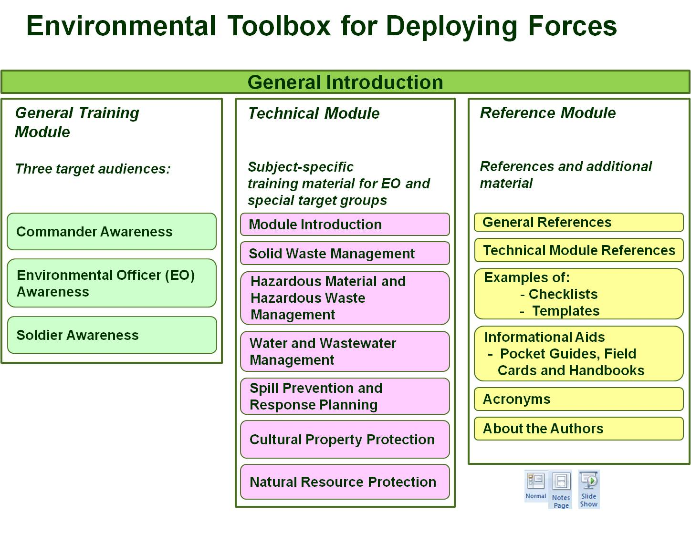
The technical module focuses on the following subject areas: solid waste management, hazardous material and hazardous waste management, water and wastewater management (both gray water and black water), spill prevention and response planning, cultural property protection, and natural resource protection. This technical information is for use primarily by the person who has the environmental protection (EP) responsibility, although there may be others who will find this information useful in particular circumstances.

The reference module offers additional materials from both international and national sources for each of the modules in this toolbox, which are based on the knowledge and research of the toolbox contributors. The references therefore do not pretend to be all-inclusive. Indeed, each user of this toolbox has the responsibility for checking other applicable documents, including his own country’s laws and requirements. The reference module contains, for example, many documents generated by NATO, the UN, and the EU. It does not, however, promise to be fully exhaustive even for these international organizations. Moreover, by the time some users employ this toolbox, there may be updated versions to some of these documents. The users are responsible for determining if there is a new version. Another important component of the reference module are the example of checklists and templates that might be used (or adapted for use) in a given deployment. In the “informational aids” section of the reference module, users will find various handouts such as pocket guides that can be used as quick references in the field. Finally, the reference module includes a list of acronyms used in this toolbox and biographical information about the contributors to this toolbox.

Caveats Concerning Use of this Toolbox and Its Scope
This toolbox is not intended to replace any national guidance or directives. Rather, it is intended to offer suggestions about the ways in which various countries might address environmental considerations in their training and education programs. The information offered here can be used either to develop or to enhance existing programs. This product, as with its precursor, is designed to be used by military personnel throughout the world. Thus, while we have drawn from our own nations’ experiences and knowledge base, we have sought to develop products that are generic in nature and can be used either as is or can be tailored to fit a particular nation’s specific requirements.

The information contained in this toolbox also does not seek to be comprehensive, but rather representative of the resources and techniques currently available. We have further focused our attention on techniques and technologies that are suitable to support up to 1,000 deployed personnel. The approaches adopted in a specific deployment will be affected by the number of troops and the planned duration of the deployment (factors which can certainly change over time).

Finally, we readily appreciate that training requirements for deploying forces are stringent and time is limited. We have therefore designed this initiative to minimize any additional time requirements, and have sought to identify ways in which some of these themes can be integrated into more traditional, already existing training and educational mandates.

Additional Environmental Factors to Consider
There are additional environmental considerations for deploying forces, more focused on management than on technologies, which are not addressed in this toolbox. While a detailed discussion of such issues is beyond the scope of this effort, at least a brief mention of some of them is merited.

In the pre-planning and planning phases, the potential environmental impact of a deployment can be minimized in several ways. First (and at least in some cases, the one requiring the longest lead time), is energy use. Enhancing the energy efficiency of overall operations can contribute to a reduced environmental footprint. For example, using less non-renewable energy—through more efficient insulation, the use of alternative energy sources, energy conservation, more effective energy distribution systems, etc.—reduces transportation and storage requirements, which can in turn help reduce the risk of spills and leaks. This is an important factor which is receiving more and more attention. However, to address the full range of energy considerations and how they can be reduced represents a stand-alone effort. While it is unquestionably a worthy endeavor, it is beyond the scope of this toolbox.

Second, adoption of different supply management techniques can affect environmental considerations. For example, reducing the amount of packaging used in shipping goods to the deployment area then reduces the amount of waste that must be treated or disposed of on-site. In addition to minimizing packaging, the potential for buying goods locally in the deployment area can be investigated. (Such initiatives must of course consider requirements of meeting necessary quality standards, reliability of suppliers, ability to supply the goods in the necessary quantities, and potential impacts on supply availability for the local community.)

Finally, in the planning phase, it is important for the decision-makers to at least be aware of environmental considerations when selecting the site for a base camp (recognizing that there are many factors to be considered in making this selection). Similarly, once a site has been selected, in the pre-deployment phase, it is important to integrate environmental factors into the camp layout. Once deployed, initiatives such as segregation of waste streams and recycling also come into play. These latter elements are, in fact, discussed in more detail in the technical module of this toolbox.

The authors are listed in the “About the Authors” in the reference module section.
See informational aids section in the Reference Module for a link to this guidebook.
The cover design was created by Hans Lundholm, HaluStudio.
This is discussed briefly in the “Environmental Considerations in Base Camp Planning” section of Chapter 3, “Pre-Deployment” in the Finland-Sweden-US, Environmental Guidebook for Military Operations (Washington, DC: 2008), pp. 13-15. In addition to being hyperlinked to this toolbox, this guidebook is also accessible by inserting its title into the “search” box at the following website: www.mil.se/en.

