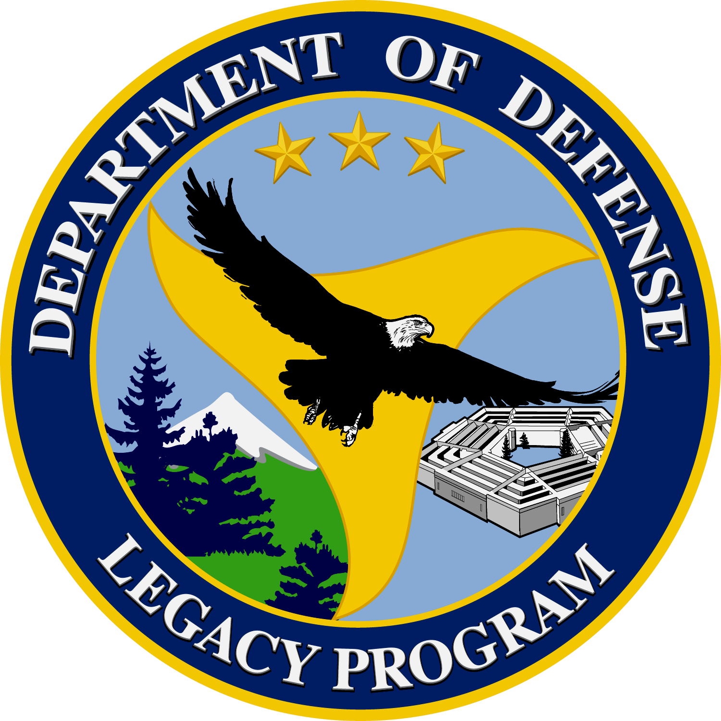
Department of Defense
Legacy Resource Management Program
Natural Selections
Volume 3, Issue 2 February 2007
Legacy Program Update
Legacy Program Announces approval of Round 1 of Legacy Projects: The Deputy Under Secretary of Defense for Installation and Environment has authorized the release of $6.734k in Legacy funding for 69 projects. Funding awards are posted online on the Legacy Tracker at http://www.dodlegacy.org (account required).
A second announcement for the remaining $400k is expected by mid March 2007.
2007 Sustaining Military Readiness Conference: The website for the DoD’s Sustaining Military Readiness Conference, also known as the Conservation Plus Conference, is up and running. In addition to the Natural and Cultural Resources sessions held at previous conferences, this expanded conference includes significant sessions on Sustainable Ranges and Compatible Land Use. Please visit:
http://www.sustainingmilitaryreadiness2007.com/
Legacy Project Highlight of the Month
Legacy Project 05-242 Threatened, Endangered, and At-risk Species (TER-S) Technology Transfer:
The Department of Defense (DoD) utilizes nearly 29 million acres of land, and thousands of square miles of air and sea space to conduct missions vital to National Security. These same areas of lands, air, and sea provide habitat for a great diversity of plants and animals, some of which are found only in areas within DoD stewardship. With 320 threatened and endangered species and nearly 550 species at risk (those under threat, but not yet protected by federal law), DoD harbors more imperiled species per acre than any other federal land management agency. This creates a challenge for DoD: how to effectively use lands, air and sea for National Security missions, while simultaneously protecting and conserving species protected by the Endangered Species Act and those at risk of needing such protection.
The project objective was to evaluate TER-S research relevant to DoD, and to bring together researchers from multiple organizations to more holistically address TER-S issues at a national level. More specifically, this Symposium and Workshop was designed to present the most up-to-date information on government and academic TER-S research relevant to DoD, stimulate collaboration and foster partnerships among participants, and identify additional areas of research needed to address TER-S and associated habitat issues facing DoD and other federal land managing agencies.
The strategy was to develop a symposium of current and recently completed TER-S research relevant to the DoD, followed by a participatory workshop to assess input and determine the best path forward.
To create the symposium agenda, the planning committee distributed a call for abstracts, and then selected presentations from among the submittals. The technical program focused on specific management areas, including current and recently completed research on mammals, birds, reptiles, amphibians, freshwater fish, invertebrates, and vascular plants. Additionally, committee members identified and invited specific plenary speakers. These speakers identified and discussed various agency views and overall approaches to TER-S conservation.
During the concluding workshop, the symposium session chairs and other selected invitees convened to discuss TER-S research needs, synthesize current information, and outline a path for future TER-S priorities.
Results from this Symposium and Workshop are helping DoD and other land managing agencies identify TER-S research needs and improve regional partnerships. With this information, DoD natural resource managers can better and more broadly (e.g., regionally) manage their lands for TER-S, thereby potentially alleviating current and future training and operational restrictions, and improving installation range readiness profiles.
This symposium marked the first time that a broad spectrum of researchers from diverse backgrounds and agencies/organizations gathered to share mutual concerns and issues regarding the need to protect TER-S and their habitats on DoD and adjacent lands. This symposium was also the genesis for a series of Regional TER-S workshops that are currently taking place. Products from the Symposium and Workshop include: increased collaboration, information exchange, and technology transfer; identification of current research initiatives and future requirements documented in the proceedings; and information (including research results) to populate a new DoD TER-S Document and Data Repository. Additionally, as a direct result of participant input, a series of DoD-sponsored regional TER-S workshops is now underway. For more information, including how to receive the proceedings or a set of CDs containing all PowerPoint presentations, please visit www.serdp.org/tesworkshop.

In The News
Don't monkey around with the Air Force
by Capt. Shannon Mann
916th ARW Public Affairs Office
January 31, 2007
1/31/2007 - SEYMOUR JOHNSON AIR FORCE BASE, N.C. (AFNEWS) -- At some point in our lives we've probably all been told to quit monkeying around, but for Senior Master Sgt. Michael Hartsfield, that was just part of his job here in late January.
In a very unusual twist of events, a privately-owned Japanese snow monkey escaped from her owner in early December after her mate died. The monkey traveled more than 15 miles over a six-week period. Unfortunately for her, the journey came to end when she decided to breach the base's security gates.
"I got a call from security forces one night saying they spotted a monkey on top of billeting," said Sergeant Hartsfield, who is the 916th Air Refueling Wing first sergeant and full-time base pest management technician. "They wanted me to come and get her, but I told them that if they couldn't get close to her then neither could I."
Sergeant Hartsfield worked in conjunction with Tech. Sgt. Tim Edwards, a reservist who works full-time for the active duty host 4th Fighter Wing.
"What we're trying to do, we've got a live trap set," Sergeant Edwards said. "We're getting her used to going in and eating the fruit."
Base officials worked closely with the U.S. Department of Agriculture to help capture the exotic primate. She finally trusted the trap set for her and was captured Jan. 29 after roaming the base for nearly a week.
The monkey was calm during capture even though her presence on base made for some interesting moments, especially since the active-duty wing was going through an operational readiness inspection when she decided to show up, along with the inspector general.
"My husband's call sign is 'monkey,'" said Maj. Wendy Gresis, the 916th ARW executive officer. "They had to change his call sign for the week because people couldn't figure out if they were referring to him or the real monkey."
The monkey was safely returned to her owner and the members of Seymour Johnson AFB are glad to have finished their monkey business.
(Air Force Reserve Command News Service)

Inside This Issue
1 | Legacy Program Update
1 | Legacy Project Highlight of the Month
1 | In The News
2 | Announcements and Events of Interest
6 | Recent Natural Resources Documents On DENIX
7 | Did You Know?
7 | Contact Us
See Legacy, page 3
Monkey, page 4

Announcements and Events of Interest
FEATURED! DoD’s “Conservation Plus” Conference: The 2007 Sustaining Military Readiness Conference will be held July 30 to August 3, at the Coronado Springs Resort in Orlando, FL. The 2007 Sustaining Military Readiness Conference, will bring together DoD professionals from the operational, environmental conservation, and planning communities along with partners from other government and non-governmental agencies and organizations to participate in training opportunities, discuss projects and programs, share lessons learned, and exchange information for the purpose of sustaining military readiness through conservation, compatible land use planning, and encroachment mitigation. For more details and registration information visit the conference website at: http://www.sustainingmilitaryreadiness2007.com/
NEW! Applied Management of Conservation Lands in Florida Conference The first conference on Applied Management of Conservation Lands in Florida will be held June 20-22, 2007 at Orlando's Caribe Royale. Convened by the Fish and Wildlife Conservation Commission, this conference will provide a forum for the exchange of new ideas, approaches, methods, and pertinent data on applied management of conservation lands in Florida, with an emphasis on vegetation management. For more information visit http://www.ces.fau.edu/amclif.
Biennial Meeting of the Western Bat Working Group The Arizona Game and Fish Department will host the Biennial Meeting of the Western Bat Working Group, April 11-14, 2007 at the Hilton Tucson East in Tucson, Arizona. The program will include symposia, contributed papers, and posters covering a broad range of bat conservation and management issues. Conference field trips will expose participants to the beauty of Arizona and the diversity of bat species in the state. Field trips are planned to: Sabino Canyon (bat netting), Agua Caliente Park (bat netting), Arizona-Sonora Desert Museum (social), and Kartchner Caverns. Please visit http://www.wbwg.org/ for more information.
2nd National Conference on Ecosystem Restoration: The 2nd National Conference on Ecosystem Restoration will be held at the Hyatt Regency Crown Center in Kansas City, MO, April 22-27, 2007. The conference will provide many opportunities to learn about ecosystem restoration efforts throughout the country and to learn about ecosystem restoration programs. For more information, visit the conference website at www.conference.ifas.ufl.edu/NCER2007.
National Military Fish and Wildlife Association “2007 Department Of Defense Natural Resources Training Workshop” March 19-23, 2007 at the Hilton Portland and Executive Tower Hotel in Portland, Oregon. The workshop will be conducted in conjunction with the North American Wildlife and Natural Resources Conference. NMFWA technical presentations will include sessions on Fire as a Management Tool, Bio-control of Invasive Species, Habitat Restoration Using Native Plants, Herpetology, Bird Conservation, Opportunities in Conservation Training, Wetlands, Invasive Species Issues, New Bird Regulations and INRMPs, and Ecology of Military Training Disturbance. There is also a DoD policy session and Service breakout sessions. Additional information and registration is available at www.nmfwa.org.
2007 National Gap Analysis Conference Featuring the Southeast Regional Gap Analysis Project September 11-13, 2007, at the Renaissance Asheville Hotel, Asheville, North Carolina. The meeting will include presentations and discussions about recent developments and applications from GAP projects across the country. Attendees will learn about the most important environmental issues in the country, particularly in the Southeast, and to discuss how GAP data sets can be used for resource management and decision-making. A special symposium will focus on conservation issues in the Southeastern U.S. and on the use of the Southeast Regional Gap Analysis Project (SEGAP) data for addressing these issues. This symposium is intended to bring together all interested individuals and agencies to explore the highest priority management needs in this region and to discuss how data resources can be used to assist managers.

Legacy, continued from page 1

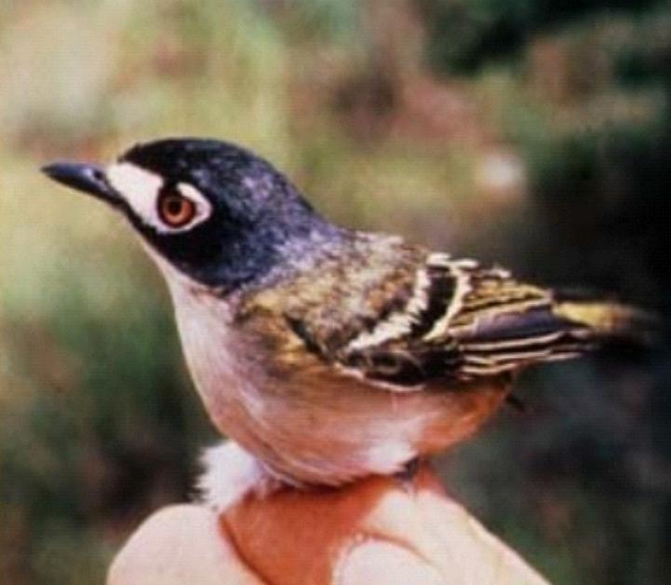
Endangered black-capped vireo (Vireo atricapilla). Photo by FWS.

Monkey, continued from page 1
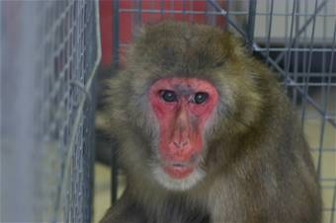
Maggie, a Japanese snow monkey, hangs out in a trap set for her in late January on Seymour Johnson Air Force Base, N.C. The exotic primate escaped her owner in December more than 15 miles from the base and was finally captured when she came on base without authorization during the active duty's Operational Readiness Inspection. Reservists from the 916th Air Refueling Wing were instrumental in her capture. (U.S. Air Force photo/Senior Master Sgt. Michael Hartsfield)

QUICK FACT!
Snow Monkeys, or Japanese macaques of Japan, live at latitudes of 41° to 31° north of the equator, the only monkeys to live that far north in the world.

Find out more about Japanese Snow Monkeys at http://www.blueplanetbiomes.org/japanese_macaque.htm

Recent Natural Resources Documents On DENIX
NEW! Actions to Abate Critical Threats, such as Encroachment and Invasive Species, Using GIS and Conservation Area Planning Across the Gulf Coastal Plain Ecosystem Partnership (GCPEP) Landscape Annual Report December 2006 (Legacy 05-280): This report details the goals and accomplishments during Phase I of this two-year project, which focuses on the initial development of this GIS database and incorporating this database into an updated GCPEP Conservation Area Plan in FL, which includes Eglin AFB. Appendices include invasive species information, a variety of resource maps and project site information.
NEW! Management Strategies For Reversing Declines In Landbirds Of Conservation Concern On Military Installations: Analysis of MAPS Data from Military Installations Outside of the Legacy-funded Network, November 15, 2006 (Legacy 05-103): This report reviews data from 46 MAPS monitoring stations that have operated in the past or are still operating (in 2006) using non-Legacy funding sources. These data showed effective demographic monitoring of 34 landbird species at 27 of the 46 stations located on DoD installations. Seven of the 34 species are listed in the Partners in Flight North American Landbird Conservation Plan as Species of Continental Importance (SCI). The goal of this analysis was to report demographic parameter values for as many species as possible, compare them to other regional- or continental-scale estimates, and recommend future monitoring efforts.
NEW! Fact Sheet: The North Carolina Sandhills Weed Management Area: Facilitating Regional, Invasive Species Management Partnerships Among DoD and Neighboring Land Stewards (Legacy 06-334): This 3 page fact sheet details a project that formed the Weed Management Area (WMA) partnership of Federal, State and local government agencies, as well as, individuals, and various interested groups that cooperatively manage non-native invasive plant species (NIS) in the NC Sandhills. The fact sheet summarizes the project objectives and accomplishments to date.
NEW! Standardized Monitoring Strategies for Burrowing Owls on DoD Installations, December 2006 (Legacy 05-243): This report details methods and protocols for trapping, tagging, measuring, monitoring and reporting on Burrowing Owls in the southwest; includes diagrams and sample data monitoring sheets.
NEW! Migratory Linkages of Burrowing Owls (Legacy 05-243): this 2 page publication summarizes the objectives, goals, benefits, and those involved in this 4 year project that studies burrowing owls, a species at risk in the southwest.
REPOSTED! State Wildlife Action Plan (SWAP) & INRMP Workshop Summary Atlanta GA 05, 09-10, 2006 (Legacy 05-281): These materials summarize the information from the State Wildlife Action Plans (SWAPs) and INMPs Workshop held in Atlanta GA on May 9-10-2006. The purpose of the workshop was to bring state (GA, NC, SC, & FL), military and USFWS personnel together to integrate SWAPs and INRMPs by identifying common problems and goals for the region. Includes the workshop workbook and information templates on follow up efforts being undertaken in the four states.
Yellow Starthistle Management Guide (Legacy 03-160): This management guide supports effective land management by compiling current information on the biology, impacts, and control of yellow starthistle. Several techniques are highlighted including mechanical tools, chemical treatments, cultural practices, and biological agents. Each technique is discussed in detail to assist land managers decide the best approach after consideration of a particular site parameters.
Migratory Linkages of Burrowing Owls on DoD Installations and Adjacent Lands: where do owls breeding on DoD installations in the southwestern U.S. spend the winter. April 2006 (Legacy 05-243): This document details the progress made on a project that investigates Burrowing Owls on DoD installations and wintering grounds throughout Mexico. Includes numbers and locations of samples taken on Davis-Monthan AFB AZ, Kirtland AFB NM, and Naval Base Coronado CA, detailed feather and specimen collection methodology and detailed information on wintering grounds, species stressors and threats throughout Mexico.

Did You Know?
They are special! The Sonoran Tiger Salamander (Ambystoma tigrinum stebbinsi) belongs to the family of mole salamanders, characterized by tunnel digging and a life spent underground. The Sonoran Tiger Salamander is native to Arizona and is protected at Fort Huachuca. This salamander is one of three tiger salamander subspecies inhabiting Arizona, including the Barred Tiger Salamander (A.t.mavortium) and the Arizona Tiger Salamander (A.t. nebulosum). Sonoran Tiger Salamanders are genetically similar to both these subspecies, and are believed to have evolved naturally from a long ago hybridization event between them Sonora tiger salamanders may begin breeding as early as January, and eggs are laid until early May. Most breeding occurs before the monsoon rains of July and August.
Terrestrial adults return to water to breed along with the branchiate adults. Although it is not known whether or not Sonora tiger salamanders exhibit site fidelity, most other Ambystoma species do. When breeding becomes imminent, the vents of the Sonora tiger salamander become swollen and turn reddish in color. After an underwater courtship and fertilization takes place, females lay 200-300 eggs. Eggs are attached to aquatic vegetation, rocks or other substrate individually or in clumps of up to 50. Eggs hatch within a few days, usually in the spring and larvae live in the water. Larvae may develop to a suitable size for metamorphosis in two months, but because many breeding sites are in permanent water, some larvae may remain in the water longer, or develop into branchiate adults without metamorphosing. Young larvae consume zooplankton, and add aquatic macroinvertebrates such as mollusks to their diets as they become larger. Major sources of larval mortality are disease, pond drying and predation by birds, fish, bullfrogs, aquatic insects and adult salamanders.
Contact Us
For further information about the Legacy Resource Management Program please contact:

L. Peter Boice | Pedro Morales
Conservation Team Leader | Natural Resource Management Specialist
 | 703-604-1933
Jane Mallory | Hillori Schenker
Natural Resource Management Specialist | Cultural Resource Management Specialist
703-604-1774 | 703-604-1724
Disclaimer
Every effort is made to provide accurate and complete information. However, with the hundreds of documents available online, often uploaded within short deadlines, we cannot guarantee that there will be no errors. With respect to documents and information referenced by means of hyperlinks on this publication, neither the U.S. Government, the U.S. Department of Defense (DoD), Plexus Scientific (website contractor) nor their employees and contractors make any warranty, expressed or implied, including the warranties of merchantability and fitness for a particular purpose with respect to documents available from Department of Defense websites, or from independent parties outside of DoD. Additionally, the U.S. Government, DoD, nor Plexus Scientific assume no legal liability for the accuracy, completeness, or usefulness of any information, product, or process disclosed herein and do not represent that use of such information, product, or process would not infringe on privately owned rights.
Requests to be added or removed to the Natural Selections distribution list may be sent to Pedro.Morales.ctr@osd.mil.

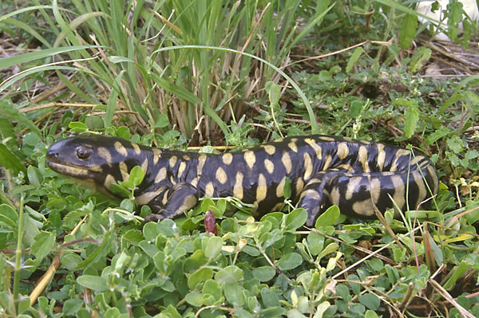
Sonoran Tiger Salamander, Photo by E. Enderson

