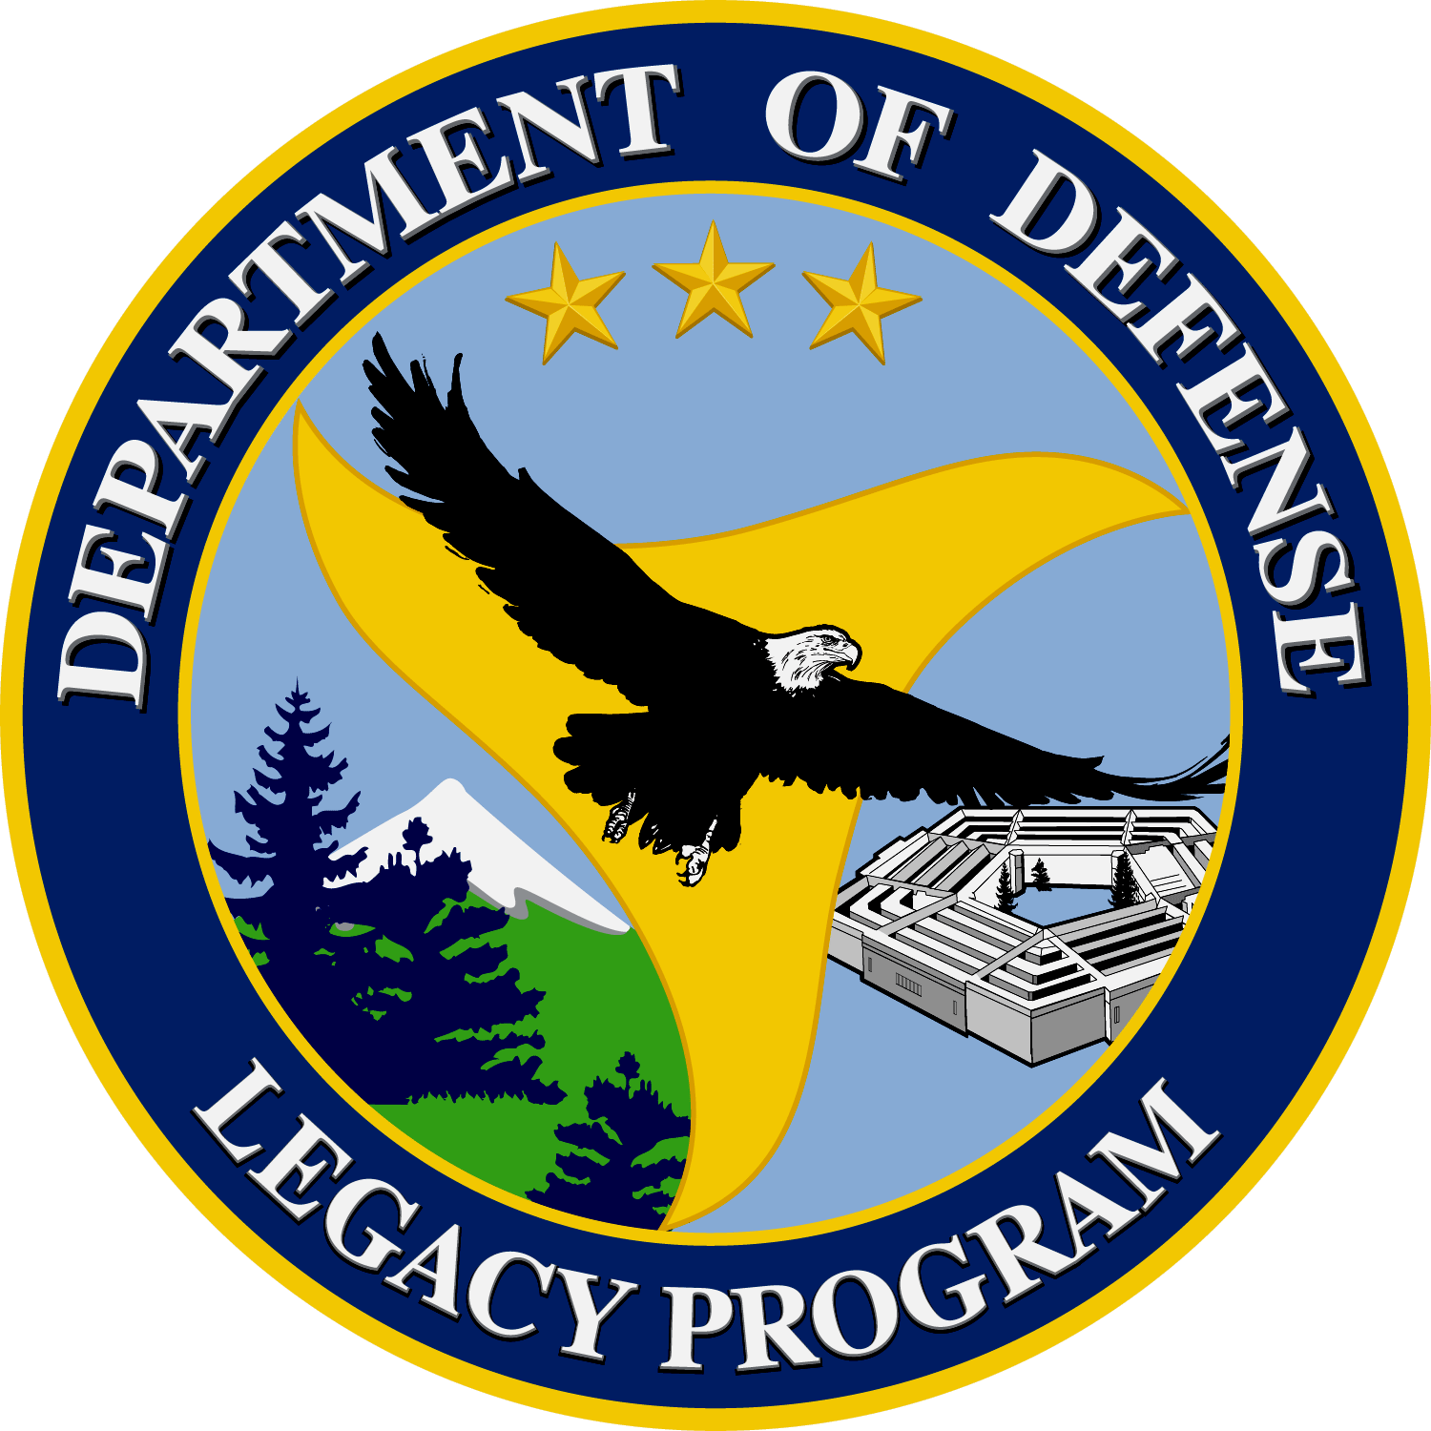 | Near Surface Sound Propagation, a Key to Alerting Right Whales of Approaching DoD Ships | 02-145

Background:
Whales spending time near the surface of the water are highly vulnerable to being struck by passing ships. This is damaging to whale populations, biodiversity and can cause damage to vessels as well. When ships travel at low speeds, the sounds created are often too low for the whales to detect, increasing the probability of strikes and whale deaths.

Objective:
This study, funded by Legacy Resource Management Program, aimed to understand the sound levels created by ships and transmitted in water and to learn how to warn whales and other vulnerable cetaceans of approaching ships. The Naval Undersea Warfare Center, Division Newport (NUWS), and Leviathan Legacy, Inc. worked together to create methods to alert whales of incoming ships to prevent further strikes and deaths. The most endangered whale in the world, the North Atlantic Right Whale, was the focus of this project.

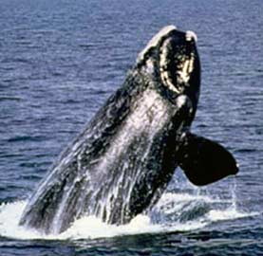
Photo by NOAA
North Atlantic Right Whale (Eubalaena glacialis)

Summary of Approach:
This project’s research was directed towards two phenomena. The first objective was to measure the bow null effect (also know as Lloyd Mirror Effect) associated with DoD ships. The second objective focused on acoustical shadowing. The Lloyd Mirror Effect is an incarnation of Snell’s Law which describes what happens to sound at the air/water interface. It was determined that sounds are cancelled out near the surface. The “Acoustical shadowing” effect is caused when propellers located above the keel of the ship create a large area in front of the ship that is void of any noise. These two effects pose problems to the ability of whales and other large sea animals to move in enough time to avoid being struck by sea vessels. Five classes of ships were used in this study to collect acoustic measurements. Measurement ranges were gathered at two water depths, 30 and 150m. Measurements were also taken at 2, 5, and 10m as speeds of the boat were varied from 5, 15, and 30KTS. Acoustical arrays collected sounds in hydrophones that were placed in travel paths of the ships and collected near surface level. Data collected from the hydrophones were analyzed and the sound speed profiles were recorded to assess effects on the near surface sound fields.

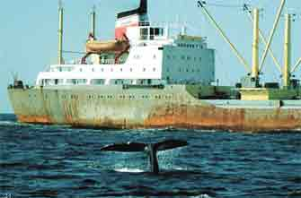
Photo by Philip Clapham of NOAA
Right Whale Swimming in Close Proximity to Cargo Ship Off the East Coast

Benefit:
The possible development of practical warning systems that may help to counter the effects of acoustic shadowing and the bow null effect for large vessels was proposed to create cost effective and successful methods to protect whales from ship collisions in coastal regions. This study provides information on near surface sounds, a phenomena that makes it difficult for Right Whales to perceive and avoid approaching ships. Understanding the sound created by ships enables the DoD to create better warning systems for its ships. This would reduce the time consuming delays resulting from maneuvering in attempt to avoid large cetaceans.

Accomplishments:
This research demonstrated why whales and other large species were not able to move in time to avoid slow moving ocean vessels. Additional data obtained about the North Atlantic Right Whale’s sense of hearing and the movement of sound underwater greatly benefits both the whales and the ships that must avoid them. The information from the study also promotes the protection of the North Atlantic Right Whales and other cetaceous species.

Contact Information:
Dr. Edmund Roy Gerstein
Leviathan Legacy Inc.
1318 S.W. 14th Street, Boca Raton, FL. 33486
(561)-338-9185
Gerstein2@aol.com

