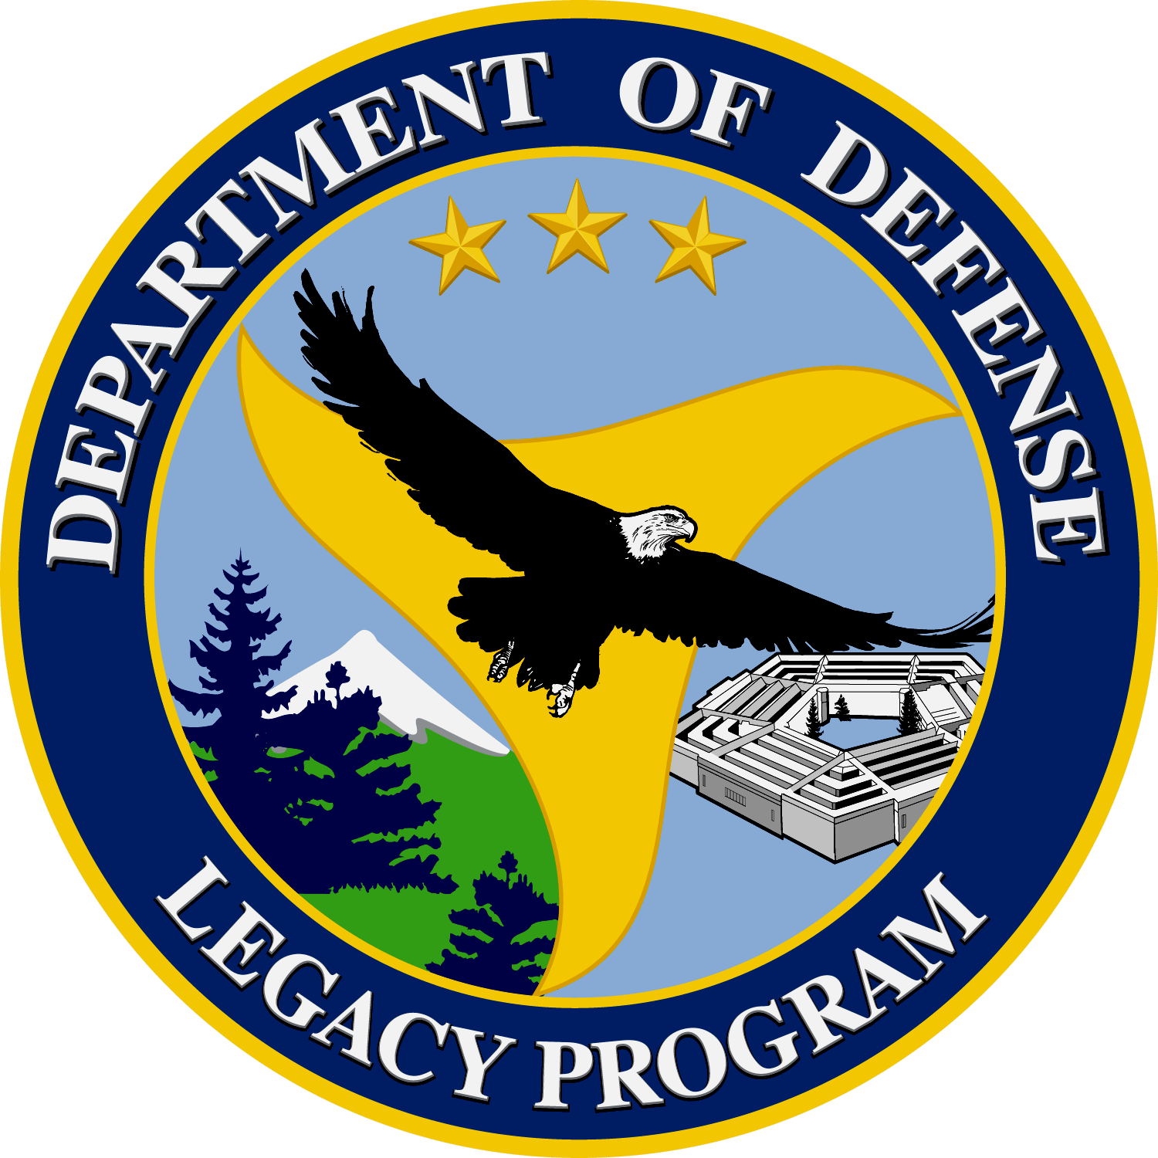
Department of Defense
Legacy Resource Management Program
Natural Selections
Volume 2, Issue 10 October 2006
Legacy Program Update
Legacy Program Pre-Proposal review meetings: Legacy Pre-proposal Review Meetings were held October 16 and 17. The Committee reviewed 206 pre-proposals (132 natural, 55 cultural, 19 integrated) with requests totaling $27.347 million. We have requested full proposals from 124 (78 natural, 38 cultural, 8 integrated). Full proposals are due November 15.
Legacy project highlight of the month
Legacy Project 00122 Watershed Management Tool Development: (DoD access only) Part of Environmental Protection Agency’s strategy focuses on protecting and improving water quality through partnerships and leadership at the local level. Federal agencies are encouraged to implement watershed management on their lands. Watershed management looks at the regulatory requirements as a whole, helps to set priorities, saves money, and involves partnerships internally and externally. Under the Clean Water Act (Section 303(d)), states are required to develop lists of impaired waters or those that do not meet water quality standards. States and territories have identified over 20,000 individual river segments, lakes, and estuaries that are polluted. For these listed waters, states must develop a total maximum daily loading (TMDL). Although many states are still working on the TMDLs, some states have established TMDLs and associated restoration requirements. TMDLs are fundamental for identifying and cleaning up the impaired and threatened waters. Restoration of the watersheds will be a large expenditure of funds. Developing a watershed management tool immediately will not only help installations in meeting existing and future TMDL requirements, but help to integrate compliance with future requirements.
Water resource management on Department of Defense (DoD) installations has evolved dramatically over the past thirty years since the Congress first enacted the Clean Water Act. Installation lands, facilities, infrastructure, and natural resources are now managed using proactive and holistic approaches to include watershed management concepts, low impact designs, and environmental management systems. In addition, installation managers have learned many lessons about what techniques actually work in the field and which do not. The objective for this project is to assemble a DoD Installation Watershed Impact Assessment Protocol with the goal of compiling
lessons learned into a single comprehensive document that is truly useful to installation managers, engineers, natural resource scientist, and master planners. The Protocol marks the beginning of DoD’s efforts to integrate efforts to manage water resources, facility and infrastructure conditions, land conditions, and natural resources. The best practices and regulations associated with watershed management, sustainable facilities, and master planning continue to evolve over time.
The Protocol serves as a reference for DoD installation managers interested in protecting the quality of the surface water, ground water, and natural habitat on and near their installation. The DoD has developed the Protocol as part of an integrated watershed management tool kit to assist site managers in cost effectively complying with regulatory requirements (e.g., Clean Water Act (CWA), Safe Drinking Water Act (SDWA)), which support the requirements of the site’s overall environmental management system (EMS). The Protocol is also designed to direct the management of other compliance requirements that will have an impact on the installation’s watershed (e.g., RCRA & CAA permits, FIFRA programs, CERCLA cleanup etc.).

The Protocol consists of a series of self-assessment forms that allow site managers to use existing information to:
- characterize the designated uses and the condition of the water resources on and surrounding the installation
- define goals for managing installation water resources, identify installation activities that may adversely affect all installation water resources or just those activities that may contribute pollutants to impaired water bodies as designated by a state’s Total Maximum Daily Load (TMDL) program
- identify opportunities to implement cost-effective conservation and pollution prevention (P2)-based projects
- prioritize proposed projects based on their cost effectiveness to mitigate the target watershed (or waterbody) impairments
- prepare project sheets for recommended solutions in an easy to -use format
- identify opportunities to reduce costs and improve program effectiveness by forming internal and external partnerships among installation offices, government organizations, landowners, citizen groups, and other stakeholders as part of an effective installation and community relation plan
- measure progress and adjust management direction as new information becomes available.
The Protocol was updated in 2005 by the Army Environmental Center. The updated version serves as both a guide and a reference to assist DoD installation environmental managers in complying with the latest Total Maximum Daily Load (TMDL) and drinking water requirements. Specifically it is written for DoD installations that drain to, or have the potential to affect, state-designated impaired waterbodies. Major updates include: conformance with the Army’s Strategy for the Environment, the requirements of the Army’s Environmental Management System (EMS), sustainability objectives, and other pertinent policy and legislation; consolidation of forms and automation of data collection fields; and review and update of websites and other available information tools.

The objective of the updated Protocol is to improve compliance by effectively identifying, assessing, and prioritizing installation site activities relative to the receiving environmental conditions (including water, air, and natural and cultural resources); to implement innovative technologies and sustainable design practices to mitigate current and potential environmental impacts before they have an effect on training; and to seek partnership opportunities whenever possible to reduce costs and leverage resources. In addition, the Protocol considers current and potential impacts from surrounding land-use owners—specifically what pollutant loads are draining onto or from the property.

In The News
Fort Lewis Naturalists Protect Disappearing Western Toads
By Bob Reinert
Northwest Guardian, Fort Lewis

With the thunder of artillery in the background, Jim Lynch tiptoed along the gravel road. He looked closely before planting each foot.
One might have imagined him avoiding mines or unexploded ordnance in a war zone. Instead, Lynch took care not to step on the waves of amphibians hopping across the road skirting Fiander Lake at the Fort Lewis, Wash., Rainier Training Area (RTA).
“I didn’t ever imagine I’d be doing this,” Lynch said. “They’re fascinating animals.” Lynch, a fish and wildlife biologist at Fort Lewis, referred to the thousands of juvenile Western Toads that migrate annually from five breeding sites at RTA. For the time being, the toad population on post seems healthy. “It appears to be doing just fine,” said Lynch, who has monitored the toads during his three years at Fort Lewis. “This population is pretty steady.”
Elsewhere, however, the toad appears to be in trouble. “It’s becoming less common,” Lynch said. “It’s currently a Federal Species of Concern, because they appear to be disappearing throughout the U.S. Right now, Fort Lewis is the only population in the [South Puget Sound] region.”
According to Lynch, there are 200-300 adult Western Toads on Fort Lewis. Each female is capable of laying 20,000 eggs, but juvenile toads have a 99 percent mortality rate.
“We have the ability to gather some information and perhaps provide it to others to help with the restoration of the species,” said Lynch of his toad studies at Fort Lewis. “I am not convinced that they are fully in decline yet, but I do recognize that their habitat is at risk.”
To protect the toads at Fort Lewis, installation Fish and Wildlife staff have used fallen trees to block off roads cutting through migration routes. “This road almost always has toads on it this time of year,” said Lynch, adding that the migration period is usually three to four weeks. Their breeding season is in April. As Lynch moved down the road on a morning in mid-July, the dark toads, measuring no more than two inches in length, moved away and quickly blended in with their surroundings. They have poisonous sacs on their skin to deter predators, but juvenile toads are always at risk.
“These guys are very slow,” Lynch said. “They get crushed.” Lynch tracks some toads each year with radio transmitters. “They can move tremendous distances,” said Lynch, pointing out that one tagged toad traveled nearly five kilometers. He tracked another that was covering approximately 200 meters per day.
The juveniles who survive can grow into much larger adult toads and live for many years. “I’ve run into some huge toads out there,” Lynch said. “The recorded [longest] lifespan of a toad in the wild ... was ... 13 years. There was a toad in captivity that lived 36 years.”
Lynch would like to do what he can to stop and reverse the decline of the Western Toad. “I would really like to find more ways we could ... reintroduce them to areas where they previously existed,” said Lynch, noting that others have tried. “They just have not succeeded.”
Lynch knows better than anyone that such efforts must be kept in balance with the mission at Fort Lewis. “The training mission has to go forward,” Lynch said. “The question is, how do we provide habitat enhancement and ecosystem management in such a way that we can work with that goal and not interfere with military training?
“By doing what we — the biologists — think is right to save the species, also is going to help the military mission. If everything works out right, everybody’s happy.”

U.S. Army Takes Delivery of GM's Latest Fuel Cell Vehicle
GM Press Release
September 21, 2006

Washington, D. C. - The U.S. Army became the first customer of General Motors Corp.'s latest fuel cell technology today as the automaker deployed the first vehicle of its next generation Chevrolet Equinox Fuel Cell vehicle fleet.
U.S. Sen. Carl Levin (D-Mich.), ranking member of the Senate Armed Services Committee and a champion of fuel cell technology, and Larry Burns, GM vice president of research and development and strategic planning, gave the Equinox Fuel Cell keys to Army Maj. Gen. Roger A. Nadeau, commander of the U.S. Army's Research, Development and Engineering Command.
On Sunday, GM announced "Project Driveway", a comprehensive market test to place 100 Chevrolet Equinox Fuel Cell vehicles with consumers in three key U.S. regions: California, Washington, D.C. and the New York City metropolitan area. A variety of drivers, including individual consumers, will begin driving the vehicles in the fall of 2007. The fuel cell vehicle the Army received today is a vehicle which will enable a direct performance assessment of GM's latest generation of fuel cell technology.
"The delivery of this vehicle today illustrates what is possible with the powerful collaboration of industry and government," said Sen. Levin. "The Army's involvement with this important program demonstrates the military's commitment to develop and test alternatives that will offer tremendous potential to reduce our dependence on oil on the battlefield. This vehicle also highlights the important work occurring in our domestic auto industry to move toward fuel cell vehicles, and the Army provides an important test bed for this technology."
The Army's fuel cell vehicle will be used for non-tactical transportation purposes, primarily on military bases in Virginia and California. It is powered by GM's fourth generation fuel cell propulsion system, offering significantly improved performance, refinement and range as compared with earlier generation vehicles. The Army's vehicle is a four-passenger crossover vehicle, with 186 miles of petroleum-free operating range. Safety features include driver and passenger airbags, anti-lock braking system (ABS) and OnStar.
"GM is demonstrating its commitment to hydrogen fuel cells as the answer for taking the automobile out of the environmental debate and reducing our dependence on petroleum," Burns said. "The U.S. Army is an important partner in validating GM's fuel cell technology in real use operation. Delivery of this vehicle is an important milestone in the Equinox Fuel Cell vehicle program announced last week, and in our ongoing relationship with the U.S. Army."
GM has a history of working with the Army on demonstrating and evaluating fuel cell vehicles. In April 2005, the U.S. Army took delivery of the Chevrolet Silverado Fuel Cell truck, the world's first compressed-hydrogen fuel cell pickup, for demonstration and evaluation in different climates and locations around the
U.S. In addition to using the Chevrolet Equinox Fuel Cell vehicle to evaluate the performance of GM's latest fuel cell technology, the military will continue to obtain first-hand experience with the operation, maintenance and logistics of fuel cell vehicles. This vehicle is an engineered prototype of the 100 vehicle Chevrolet Equinox Fuel Cell market test fleet that GM will deploy to various customers beginning in the fall of 2007.
The U.S. Army has one of the largest fleets of vehicles in the world and GM produces more than half of the non-tactical U.S. military vehicles purchased each year. Improving fuel economy and reducing the logistics of the fuel supply chain could save millions of dollars.

Inside This Issue
1 | Legacy Program Update
1 | Legacy Project Highlight of the Month
1 | In The News
2 | Announcements and Events of Interest
6 | Recent Natural Resources Documents On DENIX
9 | Did You Know?
9 | Contact Us
See Legacy, page 3
Fort Lewis, page 5

Announcements and Events of Interest
NEW! 2007 Sustaining Military Readiness Through Conservation, Compatible Land Use Planning and Encroachment Mitigation Conference July 30-August 3, 2007, at the Coronado Springs Resort, Orlando, Florida. The DoD Legacy Resource Management Program (Conservation Office), the Office of Economic Adjustment (OEA), Environmental Readiness and Safety Office, Personnel and Readiness Office, SERDP/ESTCP Office, and Operational Test and Evaluation Directorate (DOT&E) are hosting a conference in 2007 for DoD personnel and invited partners. Look for registration information and other details in the November issue of Natural Selections.
NEW! 2007 National Gap Analysis Conference Featuring the Southeast Regional Gap Analysis Project September 11-13, 2007, at the Renaissance Asheville Hotel, Asheville, North Carolina. The meeting will include presentations and discussions about recent developments and applications from GAP projects across the country. This meeting is sponsored by the U.S. Geological Survey, The Biodiversity and Spatial Information Center at NCSU, Alabama Gap at Auburn University, the Institute of Ecology at the University of Georgia, and the University of Idaho. Attendees will learn about the most important environmental issues in the country, particularly in the Southeast, and to discuss how GAP data sets can be used for resource management and decision-making. A special symposium will focus on conservation issues in the Southeastern U.S. and on the use of the Southeast Regional Gap Analysis Project (SEGAP) data for addressing these issues. This symposium is intended to bring together all interested individuals and agencies to explore the highest priority management needs in this region and to discuss how data resources can be used to assist managers.
U.S. Army Corps of Engineers Environmental and Natural Resources Conference October 29-November 2, 2007, at the Crowne Plaza Hotel in San Antonio, Texas! The conference is open to district, division and project/facility leaders who work in the environmental and natural resources management fields..
SERDP and ESTCP to Host Annual Technical Symposium & Workshop Partners in Environmental Technology Technical Symposium & Workshop, “Meeting DoD’s Environmental Challenges,” will be held November 28-30, 2006, at the Marriott Wardman Park Hotel, Washington, D.C. This annual Technical Symposium & Workshop, sponsored by the Strategic Environmental Research and Development Program (SERDP) and the Environmental Security Technology Certification Program (ESTCP), will feature comprehensive sessions highlighting research and innovative technologies that help the Department of Defense (DoD) to address increasingly complex environmental challenges. For a listing of preliminary technical session topics and other conference information, such as registration, visit http://www.serdp.org/Symposium, send an e-mail to partners@hgl.com, or call the Symposium Contact Line at (703) 736-4548.

Legacy, continued from page 1
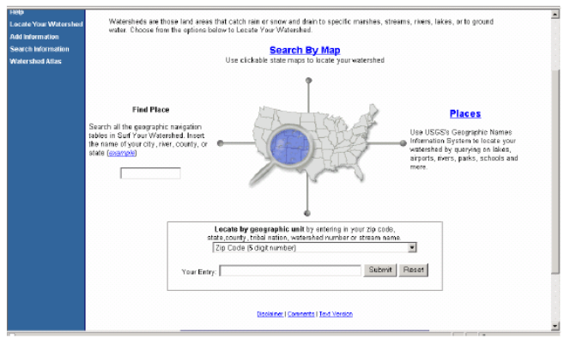
Example of EPA’s “Surf your watershed locator”.

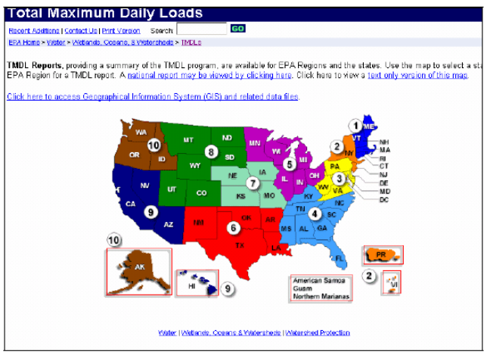
EPA’s Total Maximum Daily Loads interactive website is one of the many tools recommended by the Protocol.

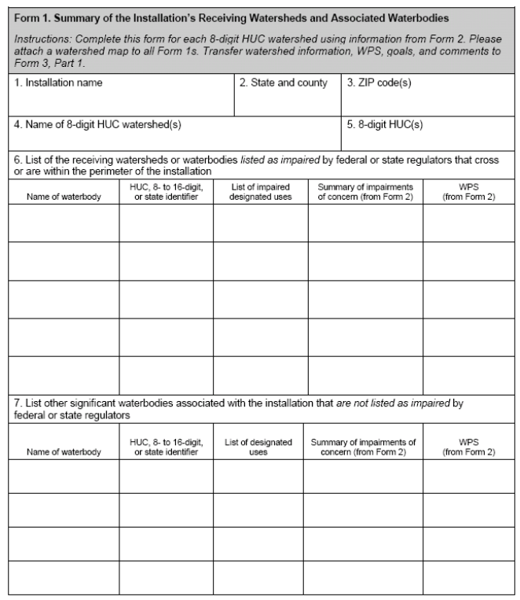
The Protocol provides many useful forms for installation managers
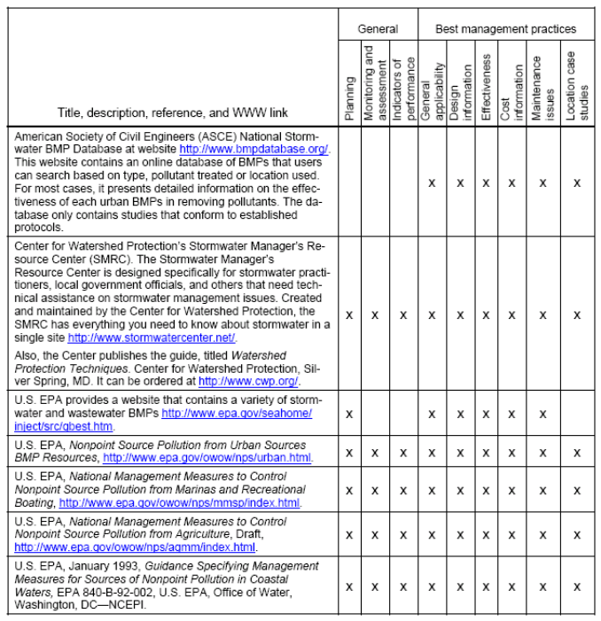
References provide a wide variety of best management practices that installation managers can review when developing solutions to identify impacts to a watershed.

Fort Lewis, continued from page 1

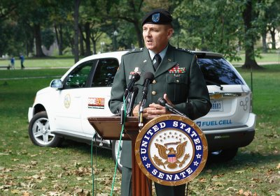

Army Maj. Gen. Roger A. Nadeau, commander of the US Army's Research, Development and Engineering Command, takes delivery of the first of a fleet of Chevrolet Equinox Fuel Cell vehicles Thursday, September 21, 2006 in Washington, DC. General Motors will place 100 Chevrolet Equinox Fuel Cell vehicles with consumers in California, Washington, D.C. and the New York City metropolitan area as part of its market test "Project Driveway." The Army's fuel cell vehicle will be used for non-tactical transportation purposes, primarily on military bases in Virginia and California. The Chevrolet Equinox Fuel Cell vehicle uses hydrogen for fuel and its only emission is water. (General Motors Photo/Tyler Mallory) (USA)

Recent Natural Resources Documents On DENIX
NEW! Fact Sheet: Department of Defense National Public Lands Day 2005 (Legacy # 5-86): This fact sheet summarizes the ongoing National Public Lands Day project accomplishments for 2005.
NEW! State Wildlife Action Plan (SWAP) & INRMP Workshop Summary Atlanta GA 05, 09-11, 2006 (Legacy 5-281): These materials summarize the information from the State Wildlife Action Plans (SWAPs) and INMPs Workshop held in Atlanta GA on May 9-10-2006. The purpose of the workshop was to bring state (GA, NC, SC, & FL), military and USFWS personnel together to integrate SWAPs and INRMPs by identifying common problems and goals for the region. Includes the workshop workbook and information templates from GA, FL, NC and SC. DoD side of Denix only.
NEW! Management Strategies for Reversing Declines in Landbirds of Conservation Concern on Military Lands: Enhanced Species-Landscape Models and Avian Demographics. September 2006 (Legacy #5-103): This document reports on enhancements to a species-landscape model that predicts effects of landscape change on a suite of adult and young birds in the eastern and central U.S. Findings will be used as the basis for subsequent management guidelines for installations in that region of the U.S.
NEW! Federal Native Plant Conservation Memorandum of Understanding (MOU) (signed 09-01-06): Signed by DoD, FHA, USGS, BLM, NPS, OSMRE, USDA and USFWS, the purpose of this MOU is to establish and describe a Federal Native Plant Conservation Committee. The Committee will identify and recommend, as appropriate, priority conservation needs for native plants and their habitats and coordinate implementation of programs for addressing those needs. A native plant species is one that occurs naturally in a particular habitat, ecosystem, or region of the United States and its Territories or Possessions, without direct or indirect human actions.
NEW! Memorandum of Understanding (MOU) between DoD and Bat Conservation International (BCI) (signed 10-11-06): The purpose of this MOU is to establish procedures for planning and conducting cooperative efforts by BCI and DoD on DoD lands. It also establishes policies and procedures for BCI to provide technical assistance to DoD to maintain or increase the productivity of bats and their habitats on DoD lands; to keep once-common bat species from being Federally-listed as threatened or endangered; and to work to recover presently listed species of bats and prevent species extinction.
NEW! Wintering Ecology of Shrubland Birds: Linking Landscape and Habitat: Annual Progress Report September 2006 (Legacy 5-241): Summarizes the data collected during the first field season of winter 2005-2006 on 8 western installations that will help gain insight to Shrubland birds with regards to habitat associations on wintering grounds, climate influences and breeding-wintering ground connectivity. Contains detailed species counts and information. Also included is a discussion of the benefits this study will have to the military. Information is preliminary and will be incorporated into a subsequent report and management plan.
NEW! Fact Sheet: Management Strategies for Reversing Declines in Landbirds of Conservation Concern on Military Installations (Legacy 5-103): Summarizes a Legacy-funded project that utilizes the Monitoring of Avian Productivity and Survivorship (MAPS) program to provide critical demographic data on 100+ species in the eastern and central US, which will be the basis for subsequent landscape management strategies to be employed in DoD installations in that region.
NEW! The North Carolina Sandhills Weed Management Area Training Workshop June 8, 2006 (Legacy 6-334): Materials consist of a presentation summarizing the invasive species problems faced by the North Carolina Sandhills region which includes Fort Bragg, defines a “weed management area” and outlines the plan of action to begin to solve the weed problem.
Multi-site Management Plan Ecoregional Conservation for the Ouachita Ecoregion (Legacy 3-179): This document consists of background information, habitat description, an assessment of ecological threats ands stresses analysis with management prescriptions for habitat in the Ouachita Highlands of Arkansas and Oklahoma, which include Little Rock Air Force Base, Fort Chaffee, and Camp Robinson.
Fact Sheet: Invasive Plants in Managed and Natural Systems: Linking Science and Management (Legacy 03-185): This fact sheet summarizes a project that involved the funding and organization of a 2003 conference that focused on invasive species and the promotion of cooperative management efforts and information sharing on and off DoD lands.
Fact Sheet: Regional Ecosystem Management in the North Carolina Sandhills (Legacy 02-161): This document summarizes a project with goals to restore and protect Red-cockaded Woodpecker populations and habitat at Ft. Bragg, NC through partnership, habitat restoration, and management and conservation program.
Fact Sheet: Conservation of Indigenous Birds on Wake Atoll (Legacy 01-134): This document summarizes a project dealing with the removal and eradication of feral cats on Wake Atoll (Marshall Islands, Micronesia) in order to preserve the indigenous birds whose numbers were declining due to heavy predation by numerous feral cats.
Fact Sheet: Survival Rates and Productivity of Landbirds on Naval Station Guantanamo Bay, Cuba (Legacy 01-1715): This document summarizes a project that gathered information on declining neotropical migrating birds in their wintering grounds on Guantanomo Bay, Cuba and led to the development of generalized field protocols and management for this specific habitat.
Fact Sheet: Greater Sage-Grouse (Centrocercus urophasianus): This joint document with USFWS describes the biology and populations of the Greater Sage-Grouse, a species found in sagebrush habitat in the western region of the US, and the military’s role in conserving this species at risk.
Fact Sheet: Chesapeake Bay Program Interagency Partnership: Submerged Aquatic Vegetation (SAV) (Legacy 00-36): This document summarizes a project that, using existing restoration planting, identified the best areas within the bay and resulted in the development of low cost, long term SAV monitoring protocols.
Fact Sheet: DDT Contamination of Migrating Birds Using White-Faced Ibis as an Indicator Species (Legacy 03-1875): This document summarizes a project that investigated the source of DDE/DDT contamination on the wintering grounds of the White-faced Ibis in California and Mexico and verified that nesting sites on NAS Fallon, NV were not the sources of contamination.
Fact Sheet: Near Surface Sound Propagation, A Key to Alerting Right Whales of Approaching DoD Ships (Legacy 02-145): This document summarizes a project that measured bow hull effects and acoustic shadowing in order to ultimately develop practical warning systems for sea vessels approaching Right Whales and other marine mammals.
Fact Sheet: Identifying Management Strategies for Reversing Declines of Neotropical Landbirds of Conservation Concern on Military Installations (Legacy 05-103): This document summarizes a project that gathered information on declining BCC Neotropical land birds to ultimately develop land management recommendations for DoD lands in the southeastern U.S.
Fact Sheet: Enhancement of Reference Collections for Bird Strike Identifications – Phase II (Legacy 03-144): This document summarizes a project that involved surveying selected military installation for feather and bird specimens to enhance the existing reference collection maintained at the Smithsonian Institute. Information from this endeavor would ultimately provide more information about species involved in Bird Air Strike Hazard (BASH) incidents.
Invasive Species Data Management Support Tools for Cooperative Weed Management Areas: (Legacy 02-1703): This document describes the computer tools designed to help inventory and manage invasive plant species on lands in AZ and other parts of the southwest. It introduces the Access tool SWIMS that can be used to database information on invasive species populations in the field and the web tool SWE

Did You Know?
Herpetofunsensational! The Island Night Lizard, Xantusia riversiana is a night lizard native to three of the Channel Islands of California: San Nicolas Island, Santa Barbara Island and San Clemente Island. The San Clemente community is a recognized subspecies, the San Clemente Night Lizard, or Xantusia riversiana reticulata. The Island Night Lizard was listed as a threatened species under the Endangered Species Act in the United States since 1977; the IUCN lists the species as vulnerable. In 2006, the US Fish and Wildlife Service, the administrating agency for the ESA, removed the San Clemente subspecies from the ESA. Better control of the munitions-sparked wildfires may have been a reason.
This lizard's preferred habitat is coastal scrub made up of dense boxthorn and cacti thickets. Like other night lizards, it bears live young rather than laying eggs. The island lizards are much larger than their cousins in the genus, the desert night lizards, Xantusia vigilis of southern California.
Contact Us
For further information about the Legacy Resource Management Program please contact:

L. Peter Boice | Pedro Morales
Conservation Team Leader | Natural Resource Management Specialist
 | 703-604-1933
Jane Mallory | Hillori Schenker
Natural Resource Management Specialist | Cultural Resource Management Specialist
703-604-1774 | 703-604-1724

Disclaimer
Every effort is made to provide accurate and complete information. However, with the hundreds of documents available online, often uploaded within short deadlines, we cannot guarantee that there will be no errors. With respect to documents and information referenced by means of hyperlinks on this publication, neither the U.S. Government, the U.S. Department of Defense (DoD), Plexus Scientific (website contractor) nor their employees and contractors make any warranty, expressed or implied, including the warranties of merchantability and fitness for a particular purpose with respect to documents available from Department of Defense websites, or from independent parties outside of DoD. Additionally, the U.S. Government, DoD, nor Plexus Scientific assume no legal liability for the accuracy, completeness, or usefulness of any information, product, or process disclosed herein and do not represent that use of such information, product, or process would not infringe on privately owned rights.
Requests to be added or removed to the Natural Selections distribution list may be sent to Pedro.Morales.ctr@osd.mil.

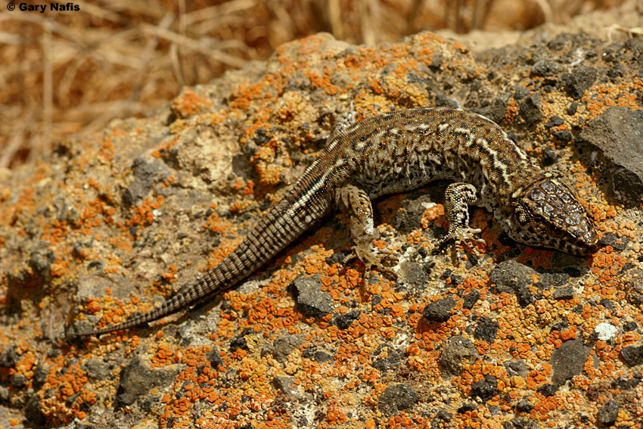
San Clemente Island Night Lizard Photo courtesy of Gary Nafis

